

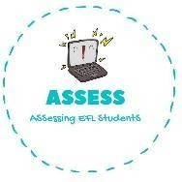1. Write the correct name of each image.

|  |  |  |
| --- | --- | --- |
| **Name: Surname: Nber: Grade/Class:** | | |
| **Assessment:** | **Date:** | |
| **Teacher’s signature:** | **Parent’s signature:** |

ENGLISH EXAM

Writing

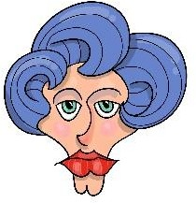 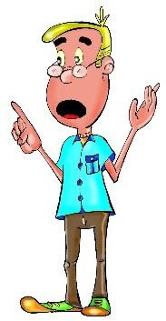 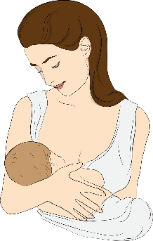

a _ _ _ u_ _ _ _ m _ _ _ _ _

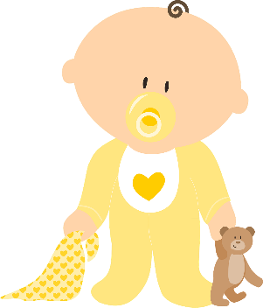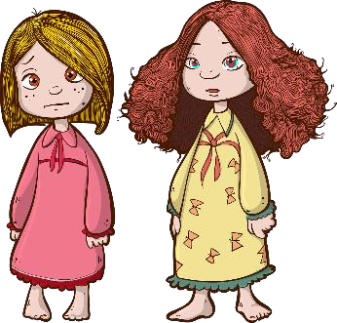

b _ _ _ _ _ _ s _ _ _ _ _ f _ _ _ _ _

Assessing EFL Students