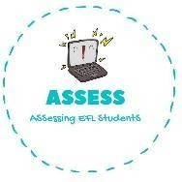
ENGLISH WORKSHEET

Writing

Name: Surname: N^{ber}: Grade/Class:
Assessment: | Date:
 | Teacher’s signature: | Parent’s signature:

1. Create a family tree. Use the specific words from the vocabulary.

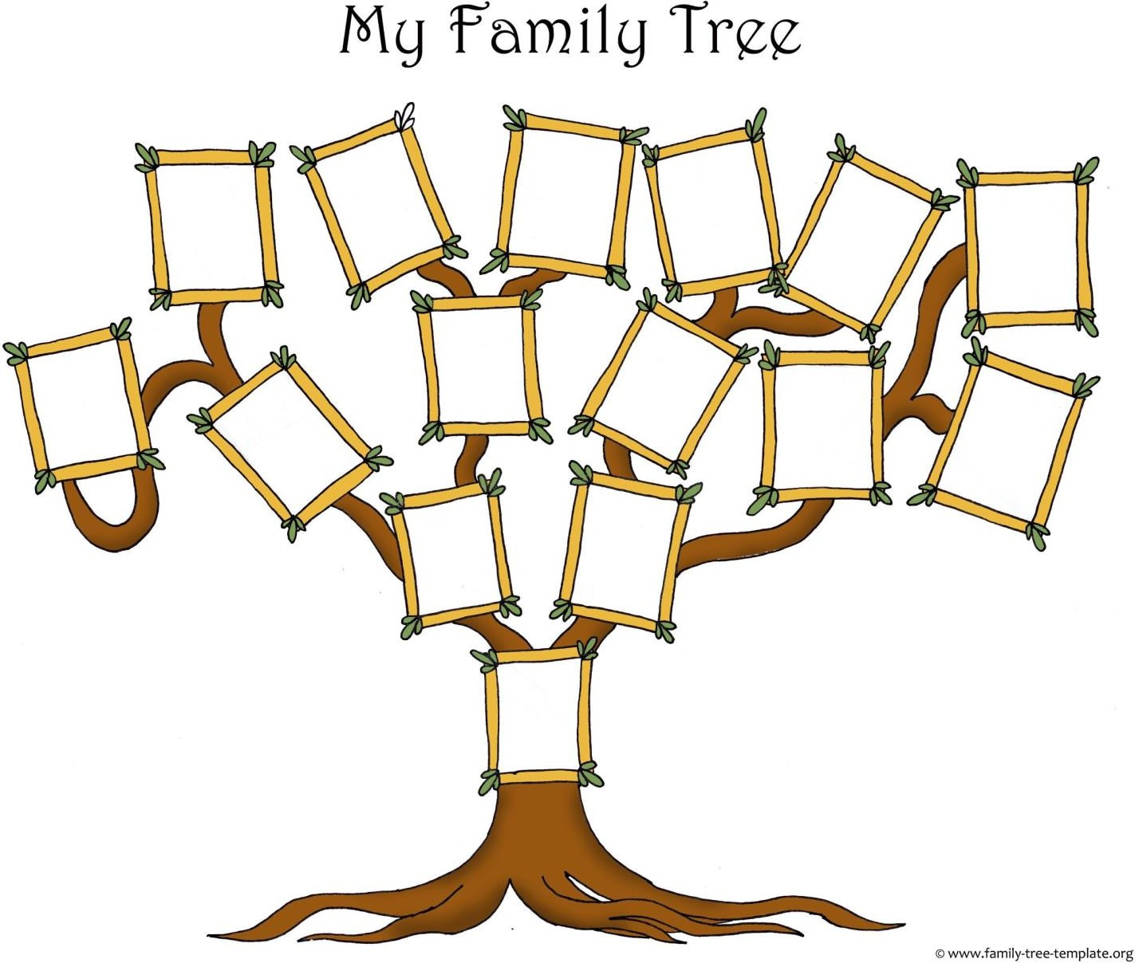

Assessing EFL Students

