TOPIC: FAMILY | SUBTOPICS: _Naming family members | LEVEL: _A1
Name: Surname: N^{ber}: Grade/Class:

Put the name under the correspondent drawing.
Grandfather, grandmother, grandma, grandpa, father, mother, dad, mum, brother, sister, daughter, son, aunt, uncle, cousin.

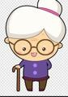
1 2 3 4 5

6 7 8 9 10
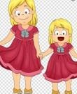

11 12 13 14 15
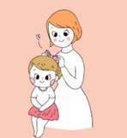
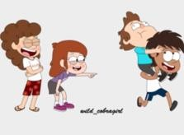

Look the images and answer the questions:
- Who is he?
He is my b

- Who is she?
She is my m

- Who is this?
This is my g

- Who is that?
That is my a

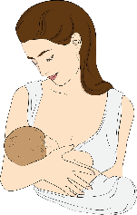
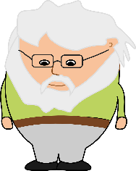
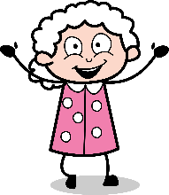
1. 2. 3. 4.

