Name: ____________________________ Surname: ____________________________ N^{ber}: ____ Grade/Class: _____
Assessment: _____________________________ | Date: ___________________________________________________
 | Teacher’s signature:  ___________________________ | Parent’s signature:  ___________________________

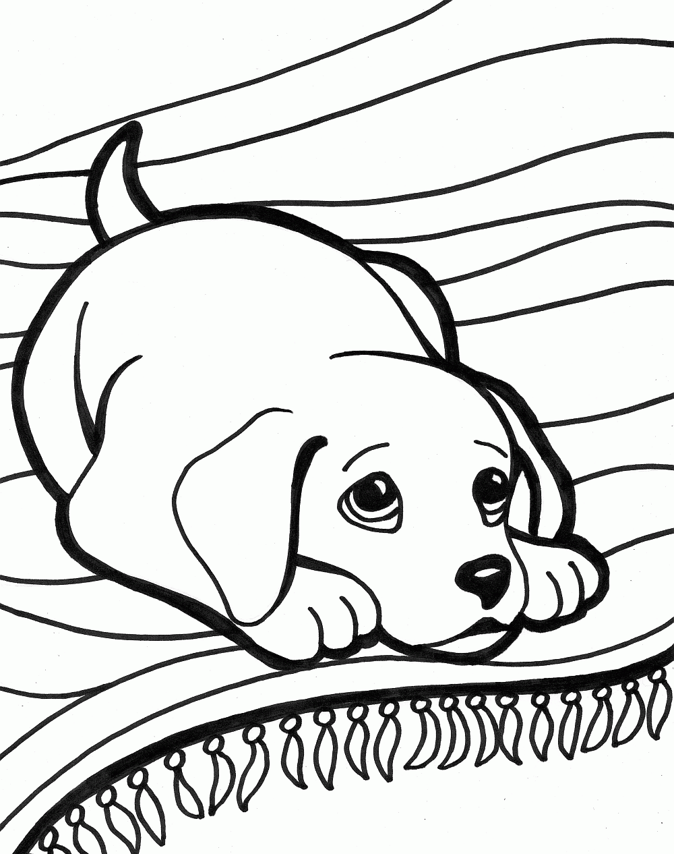
Listen and number the pets, then colour according to the instructions.

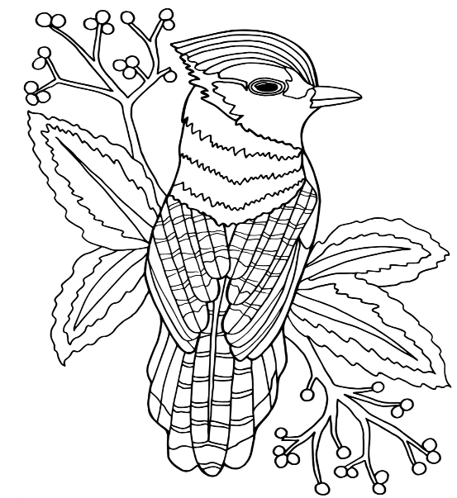

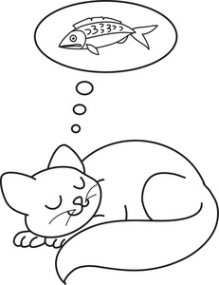

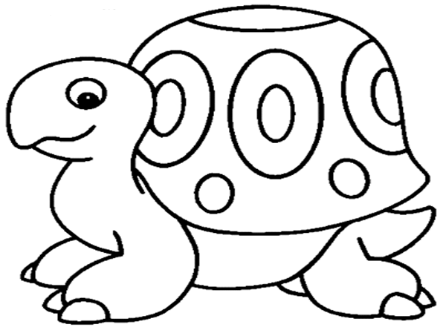

Transcript:

Number one is a dog laying on a rug.
Number two is a cat dreaming about fish.
Number three is a turtle that looks happy.
Number four is a bird in a tree.

Color the dog brown.
Color the cat yellow.
Color the turtle green.
Color the bird red, blue and orange.

