TOPIC: PETS | SUBTOPICS: PLURALS | LEVEL: A1
Name: ____________________________ Surname: ____________________________ N^{ber}: ____ Grade/Class: _____

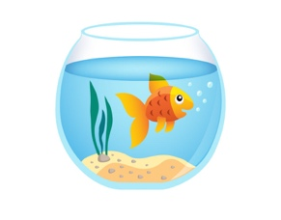
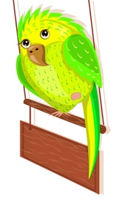
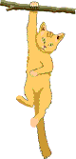
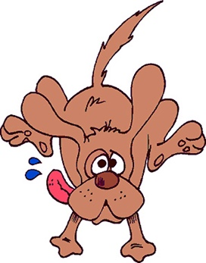
Swim Run Climb Fly Swing
This Photo by Unknown Author is licensed under CC BY
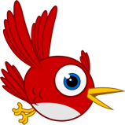

I swim run climb fly swing
You swim run climb fly swing
He/she swims runs climbs flies swings
We swim run climb fly swing
You(all) swim run climb fly swing
They swim run climb fly swing

Fill in the blanks
The yellow goldfish _______ in the water.
The brown dog _____ after the stick.
The orange cat ________ the tree.
The blue bird _____ in the air.
The green parrot _______on the perch.

