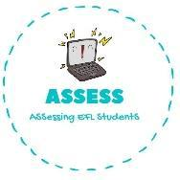
ENGLISH WORKSHEET

TOPIC: ZOO ANIMALS | SUBTOPICS: NUMBERS, PLURALS |  | LEVEL: A1
Name: ____________________________ Surname: ____________________________ |  | N^{ber}: ____ Grade/Class: _____

Number the animals

1.One 2.Two 3.Three 4.Four 5.Five 6.Six 7.Seven 8.Eight 9.Nine 10.Ten
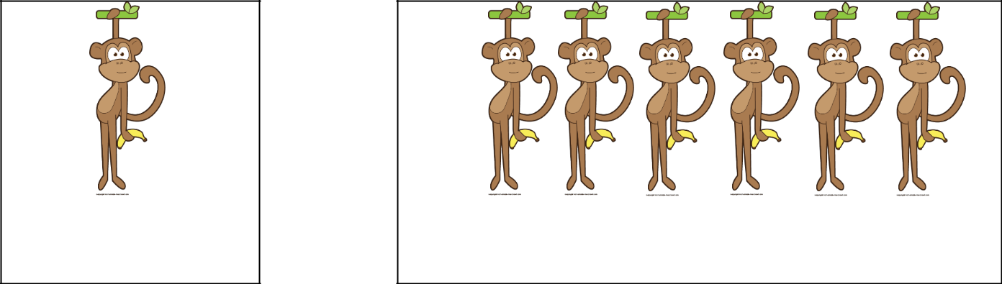

One monkey

_____ monkeys

One lion |  | _____ lions
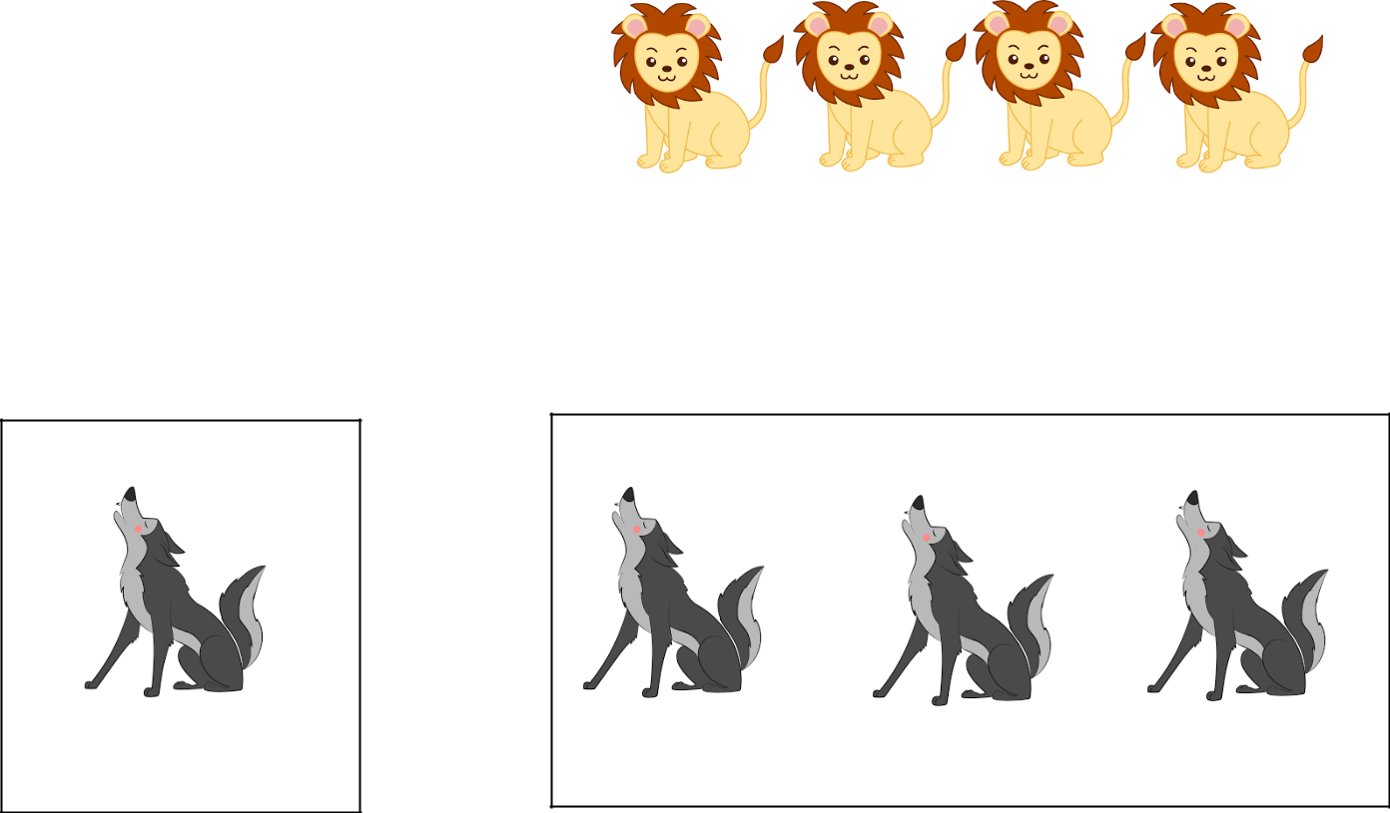

One wolf

_____ wolves

Assessing EFL Students

