Name: ____________________________ Surname: ____________________________ N^{ber}: ____ Grade/Class: _____
Assessment: _____________________________ | Date: ___________________________________________________
 | Teacher’s signature:  ___________________________ | Parent’s signature:  ___________________________
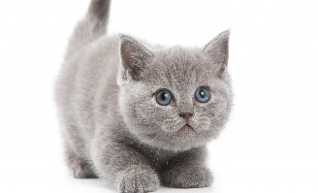
This Photo by Unknown Author is licensed under CC BY-NC
Read the text and answer the questions with true and false.

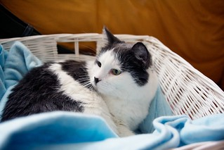
This is my cat. My cat’s name is Molly. Molly is grey and is still a kitten. She is only one month old.

She lives in my home. She sleeps near my desk.

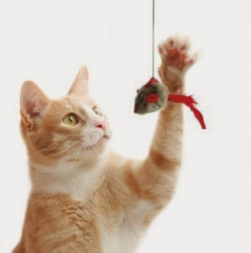
She is very playful and likes to try and catch a mouse on a string.

Molly loves milk and fish.

She also likes to climb the trees in the garden.

Molly likes to sleep on my lap.

She is my best friend and I love her.
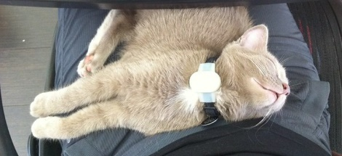
- The cat’s name is Molly. _________________
- She is two months old. _________________
- She sleeps on my desk. _________________
- She does not like to play. _________________
- She loves fish. _________________
- She never climbs trees. _________________
- She likes to sleep. _________________
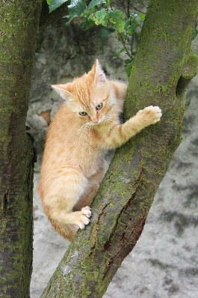

Key:
- True
- False
- False
- False
- True
- False
- True

