Name: ____________________________ Surname: ____________________________ N^{ber}: ____ Grade/Class: _____
Assessment: _____________________________ | Date: ___________________________________________________
 | Teacher’s signature:  ___________________________ | Parent’s signature:  ___________________________

Read the text, look at the picture and answer the questions with one word.
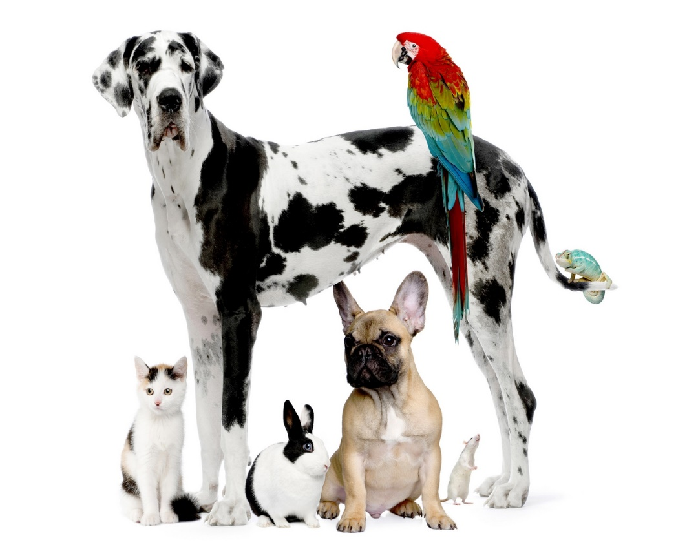
These are all my pets. I have a big dog. The dog is black and white. His name is Baxter.
I also have a small dog. His name is Puddle. He is brown and has big ears.
My mouse is white. I call him Mickey.
My parrot, Polly, has many colours, red, green, blue and yellow.
My cat is very quiet, her name is Fluffy.
My rabbit likes to eat carrots, he is old. His name is Bunny.

- What is the name of the big dog? ___________________________________________
- What colour is the other dog? ___________________________________________
- Is the mouse named Mickey? ___________________________________________
- Which pet’s name is Bunny? ___________________________________________
- Who’s name is Puddle? ___________________________________________
- What colour is Polly? ___________________________________________
- Is the cat named Silver? ___________________________________________

These are all my pets. I have a big dog. The dog is black and white. His name is Baxter.
I also have a smaller dog. His name is Puddle. He is brown and has big ears.
My mouse is white. I call him Mickey.
My parrot, Polly, has many colors.
My cat is very quiet, her name is Fluffy.
My rabbit likes to eat carrots, he is already old.

