Name: ____________________________ Surname: ____________________________ N^{ber}: ____ Grade/Class: _____
Assessment: _____________________________  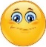  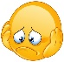  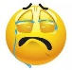 | Date: ___________________________________________________
 | Teacher’s signature:  ___________________________ | Parent’s signature:  ___________________________

Read and look. Put a tick if it’s correct and a cross if it’s wrong .
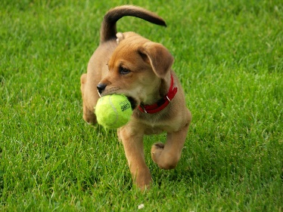

- The turtle is swimming.

- The parrot is flying.

- The cat is drinking milk.

- The dog is sleeping.

- The rabbit is running.

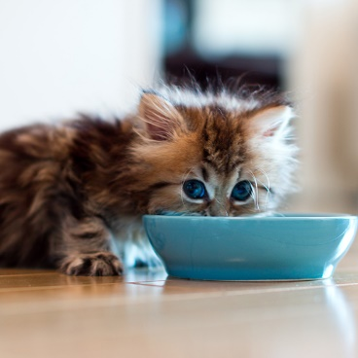

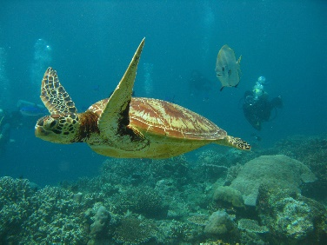

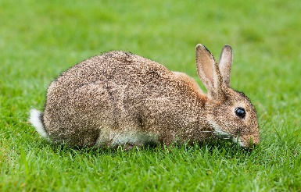

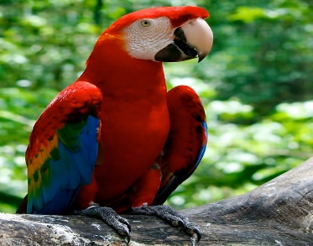
This Photo by Unknown Author is licensed under CC BY-SA-NC

