Name: ____________________________ Surname: ____________________________ N^{ber}: ____ Grade/Class: _____
Assessment: _____________________________ | Date: ___________________________________________________
 | Teacher’s signature:  ___________________________ | Parent’s signature:  ___________________________
- Talk about the pets and who likes or doesn’t like them.

Martin Todd Paula
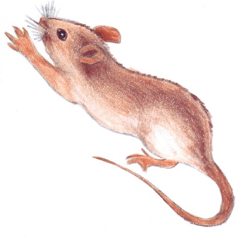
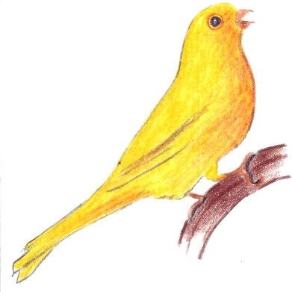
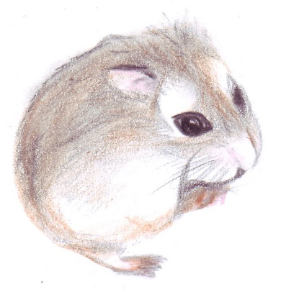

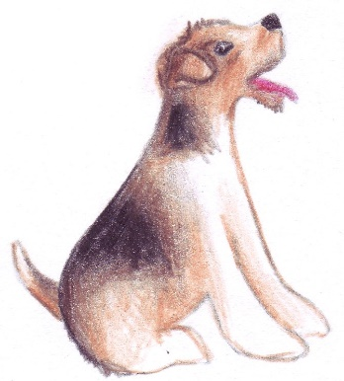
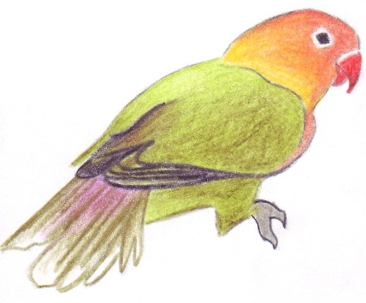
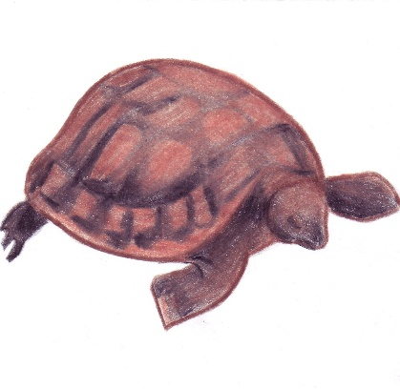
Adam Janet Tina

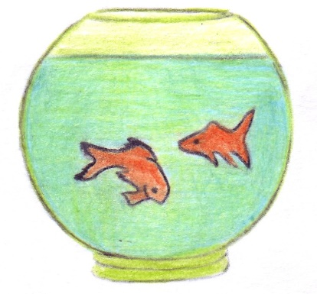
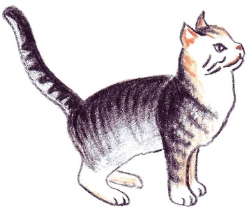
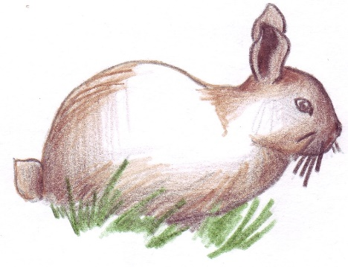
Sarah Tommy Peter

- What pets do you like? What pets don’t you like?

