Name: ____________________________ Surname: ____________________________ N^{ber}: ____ Grade/Class: _____
Assessment: _____________________________ | Date: ___________________________________________________
 | Teacher’s signature:  ___________________________ | Parent’s signature:  ___________________________

Describe the dogs and give them a name.
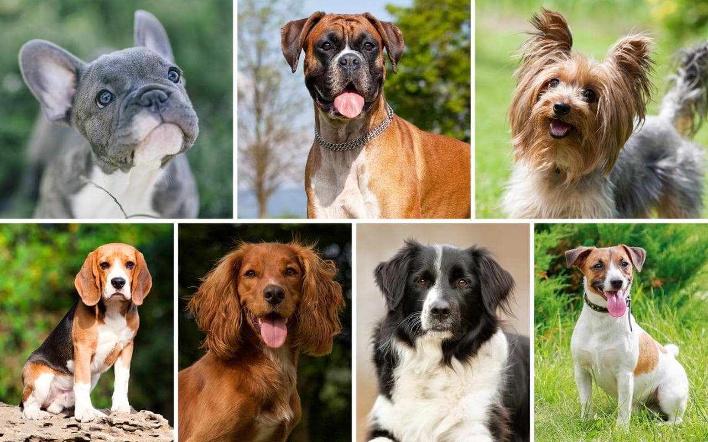
Example: The dog has got blue eyes and grey fur. He is called Bob. He is one year old. He has hairy ears.

