Name: ____________________________ Surname: ____________________________ N^{ber}: ____ Grade/Class: _____
Assessment: _____________________________ | Date: ___________________________________________________
 | Teacher’s signature:  ___________________________ | Parent’s signature:  ___________________________
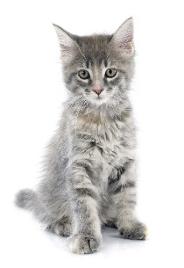
Look at the pictures and describe what the pets are like and what they look like.
Example: The cat is grey. It has two ears. It has a tail and four paws. Cats are very soft.

