|  |  |  |
| --- | --- | --- |
| **TOPIC: PETS** | **SUBTOPICS: VOCABULARY, COLOURS** | **LEVEL: A1** |
| **Name:** ____________________________ **Surname:** ____________________________ **Nber: ____ Grade/Class:** _____ | | |

**PETS**

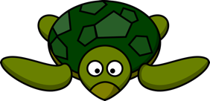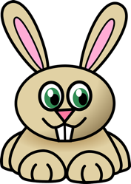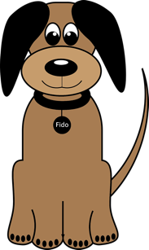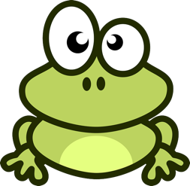



Turtle

Mouse

Frog

Dog

Rabbit



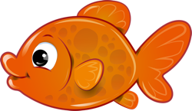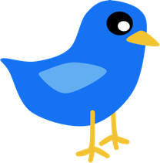

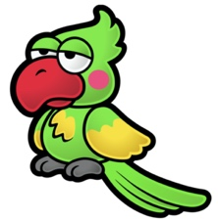

[This Photo](https://www.mariowiki.com/Parrot_(character)) by Unknown Author is licensed under [CC BY-SA](https://creativecommons.org/licenses/by-sa/3.0/)

Hamster

Goldfish

Cat

Parrot

Bird



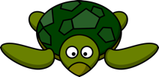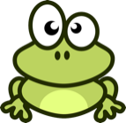Draw a line from the word to the picture

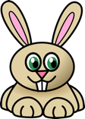

Dog

Cat

Bird

Parrot

Turtle

Mouse

Rabbit

Frog

Goldfish

Hamster

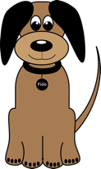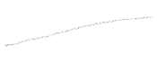



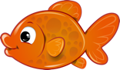





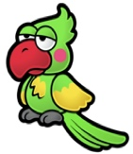

[This Photo](https://www.mariowiki.com/Parrot_(character)) by Unknown Author is licensed under [CC BY-SA](https://creativecommons.org/licenses/by-sa/3.0/)



Grey Green. Orange Brown White

Yellow Red Black Purple Blue

Draw and colour the pets

A grey mouse A yellow goldfish A brown dog

An orange cat A green frog A blue bird