Name: ____________________________ Surname: ____________________________ N^{ber}: ____ Grade/Class: _____
Assessment: _____________________________ | Date: ___________________________________________________
 | Teacher’s signature:  ___________________________ | Parent’s signature:  ___________________________

1) Look at the pictures, fill in the gaps and circle the correct answer.

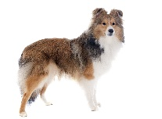
a)
Do you like d __ gs?
Yes, I do. / No, I don’t.
Yes, I do. / No, I don’t.

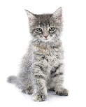
b)
Do you like __ a __ s?

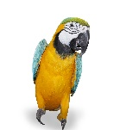
c)
Do you like p__ __ __ ots?
Yes, I do. / No, I don’t.

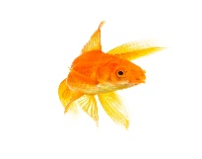
d)
Do you like g__ l__f__s__?
Yes, I do. / No, I don’t.
Yes, I do. / No, I don’t.

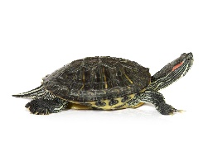
e)
Do you like t__ __tl__s?

2) And you?

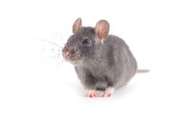
a)
Do you like mice?
______ , _____ ______.

______ , _____ ______.

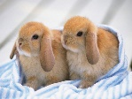
b)
Do you like bunnies?

