Name: ____________________________ Surname: ____________________________ N^{ber}: ____ Grade/Class: _____
Assessment: _____________________________ | Date: ___________________________________________________
 | Teacher’s signature:  ___________________________ | Parent’s signature:  ___________________________

Match the name of the pets with the picture. Then write the singular / plural forms.

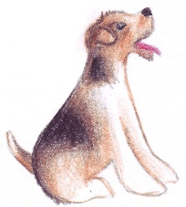
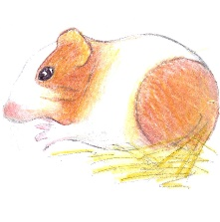
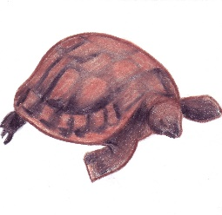
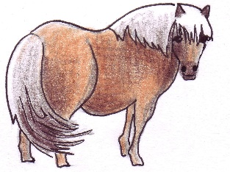

Turtle / Cat / Dog / Mouse / Pony / Guinea pig / Horse / Hamster

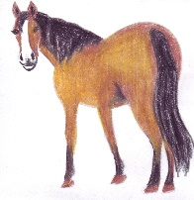
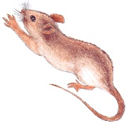
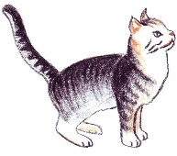
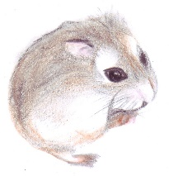

Singular Plural
Horse
Guinea pigs
Turtle
Hamsters
Dog
Mice
Cat
Ponies

