Name: ____________________________ Surname: ____________________________ N^{ber}: ____ Grade/Class: _____
Assessment: _____________________________ | Date: ___________________________________________________
 | Teacher’s signature:  ___________________________ | Parent’s signature:  ___________________________

Match the word to the picture

- b. c. d. e.
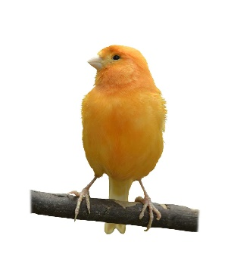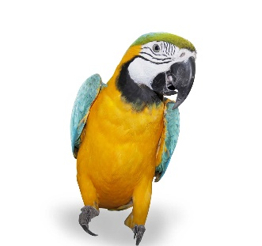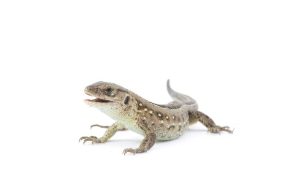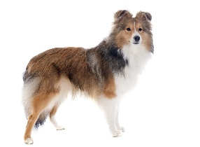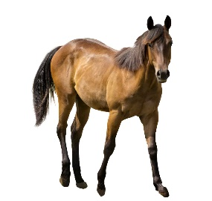

Horse Guinea pig Parrot Dog Cat

Lizard Canary Hamster Rabbit Goldfish

f. g. h. i. j.
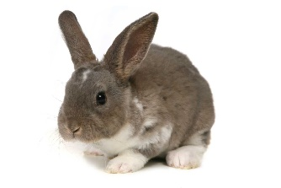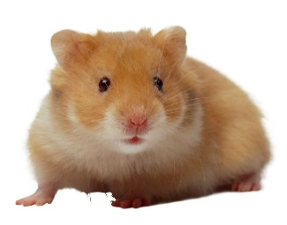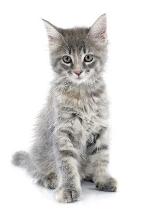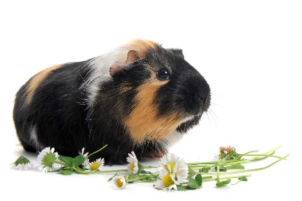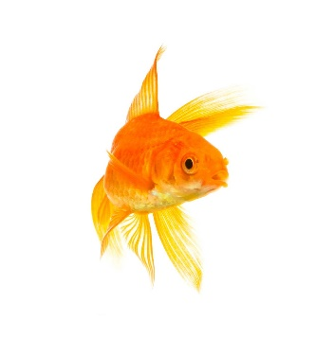

Key:
- Canary
- Parrot
- Lizard
- Dog
- Horse
- Rabbit
- Hamster
- Cat
- Guinea pig
- Gold fish

Key:

Crocodile – crocodiles
Canary – canaries

