|  |  |  |
| --- | --- | --- |
| **TOPIC: PETS** | **SUBTOPICS: VOCABULARY** | **LEVEL: A2** |
| **Name:** ____________________________ **Surname:** ____________________________ **Nber: ____ Grade/Class:** _____ | | |

Match the words to the pictures.

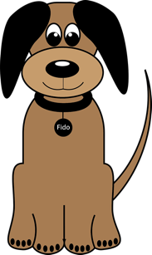

Cat

Dog

Rabbit

Turtle

Hamster

Goldfish

Parrot

Frog

Mouse

Bird

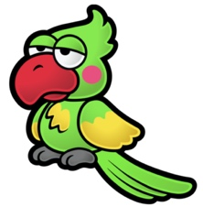

[This Photo](https://www.mariowiki.com/Parrot_(character)) by Unknown Author is licensed under [CC BY-SA](https://creativecommons.org/licenses/by-sa/3.0/)





