Name: ____________________________ Surname: ____________________________ N^{ber}: ____ Grade/Class: _____
Assessment: _____________________________ | Date: ___________________________________________________
 | Teacher’s signature:  ___________________________ | Parent’s signature:  ___________________________

Find the animals and write the name of the animal on the line.

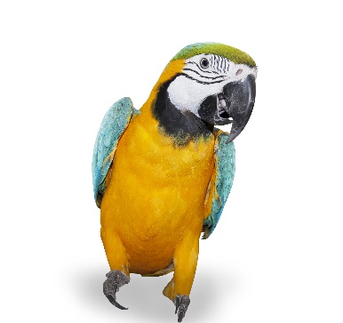
TURTLEGOLDFISHPARROTHAMSTERRABBITFROG
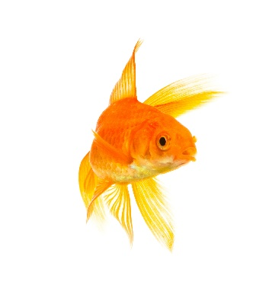
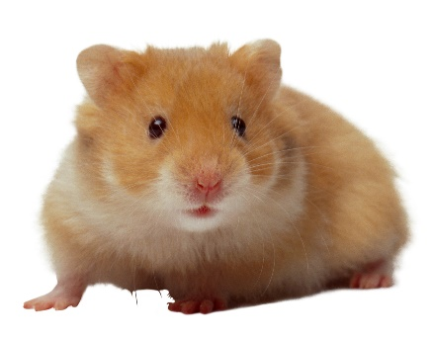

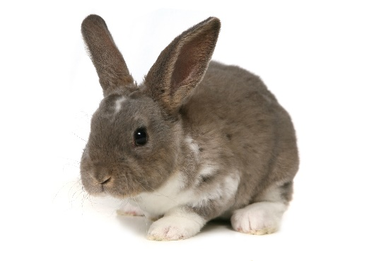
- ____________________ b) ____________________ c) ____________________
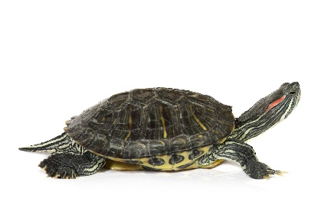
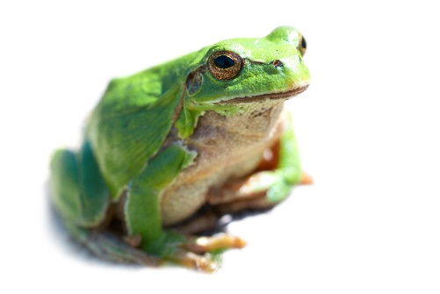

- ____________________ e) ____________________ f) ____________________

