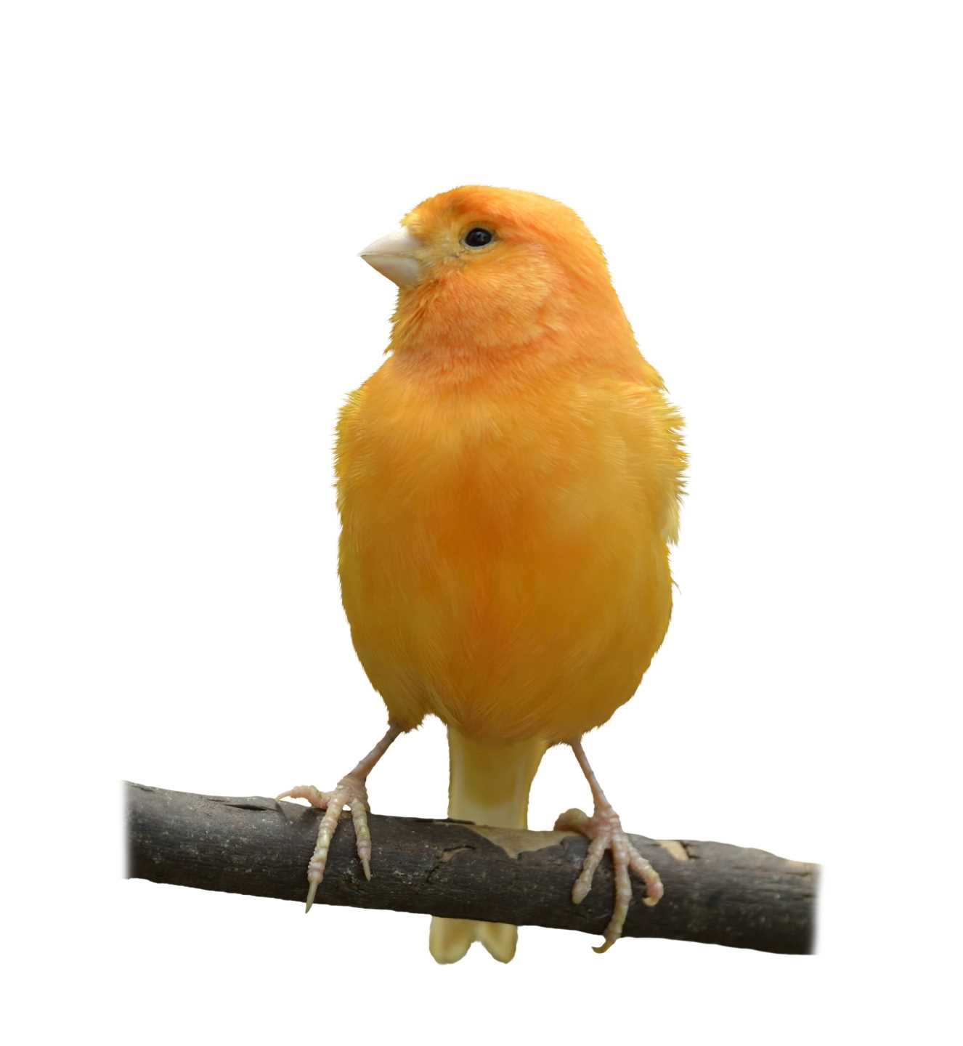
Name: ____________________________ Surname: ____________________________ N^{ber}: ____ Grade/Class: _____
Assessment: _____________________________ | Date: ___________________________________________________
 | Teacher’s signature:  ___________________________ | Parent’s signature:  ___________________________

- Unscramble the words and match with the correct pet
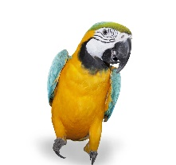
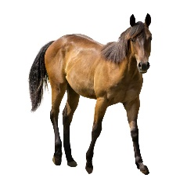
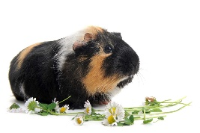
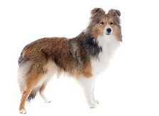
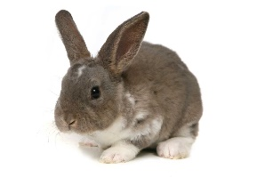
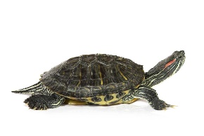
e o s h r ___________ i r t a b b ___________

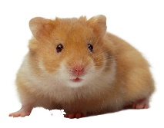
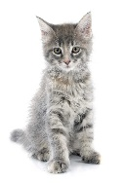
g l o d h s i f ___________ p n o y ___________

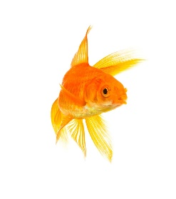
i n e g u a g i p ___________ t a c ___________
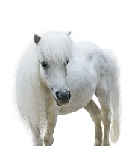

e t l u t r ___________ h t e m a s r ___________

- My two favourite pets are… ________________ and ________________

