ENGLISH WORKSHEET

TOPIC: ZOO ANIMALS | SUBTOPICS: VOCABULARY |  | LEVEL: A1
Name: ____________________________ Surname: ____________________________ |  | N^{ber}: ____ Grade/Class: _____
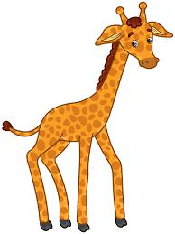

AT THE ZOO
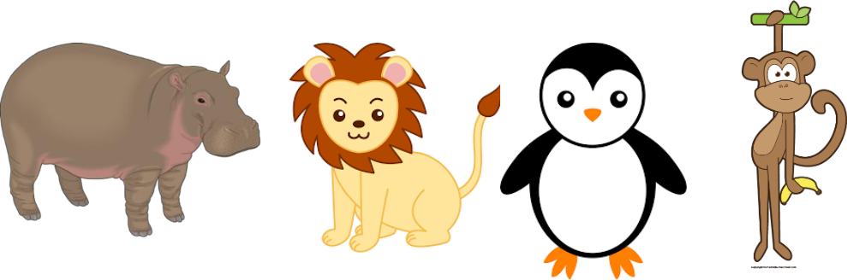

Hippo |  | Lion |  | Penguin |  | Monkey |  | Giraffe
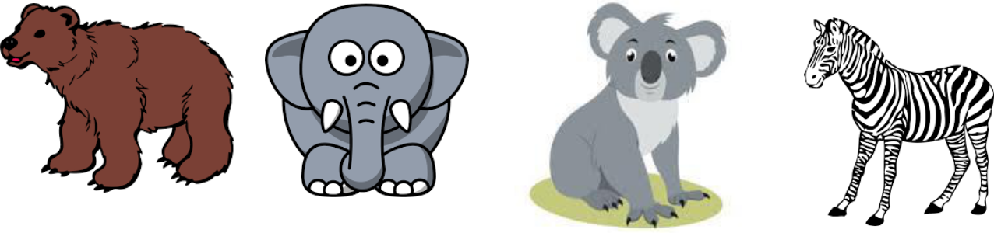

Bear |  | Elephant |  | Koala |  | Zebra
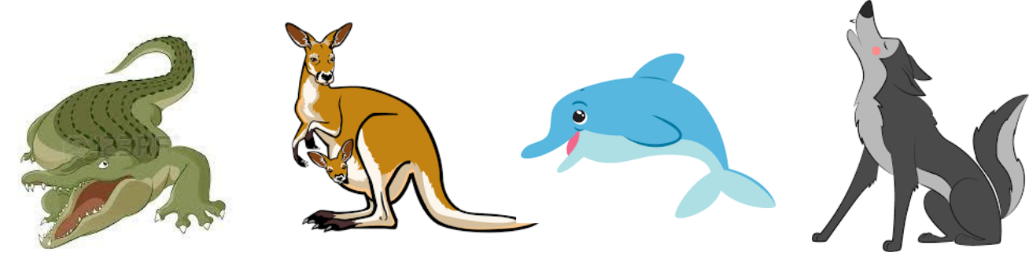

Crocodile |  | Kangaroo |  | Dolphin |  | Wolf

Assessing EFL Students

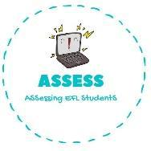
ENGLISH WORKSHEET

Draw a line from the word to the picture

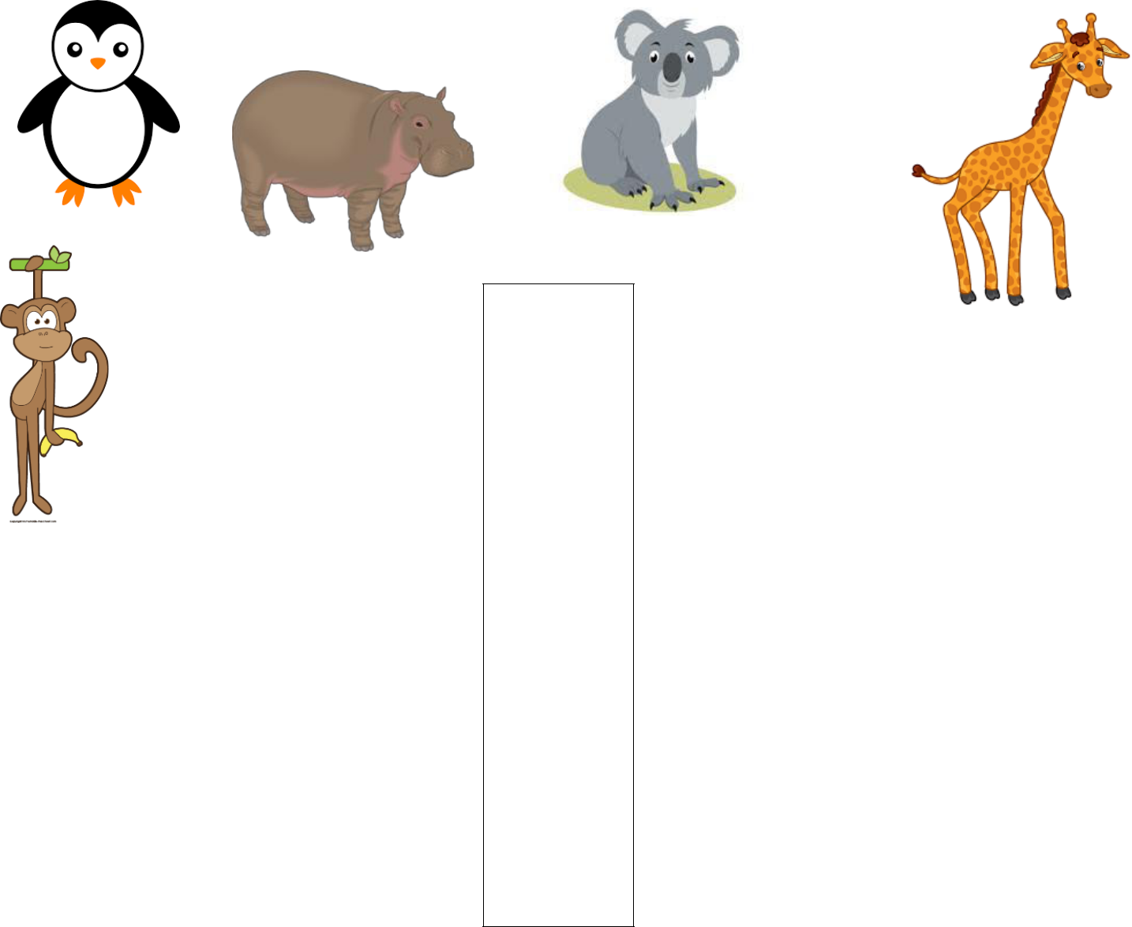

Wolf

Dolphin

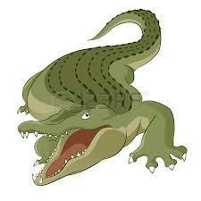
Elephant

Zebra

Kangaroo
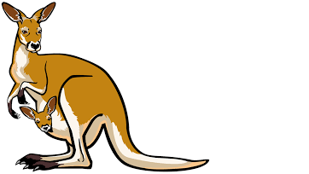
Crocodile

Bear

Monkey

Hippo

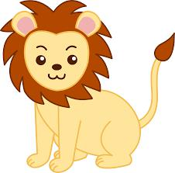
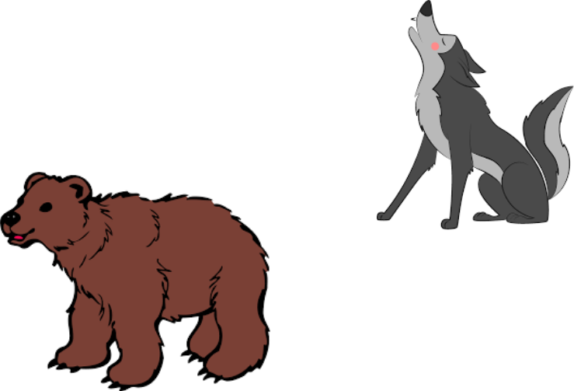
Lion

Penguin

Koala

Giraffe

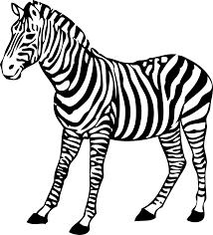

Assessing EFL Students

