Name: ____________________________ Surname: ____________________________ N^{ber}: ____ Grade/Class: _____
Assessment: _____________________________ | Date: ___________________________________________________
 | Teacher’s signature:  ___________________________ | Parent’s signature:  ___________________________

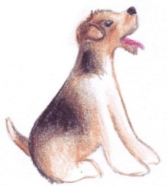
Look at the picture and rewrite the sentence.

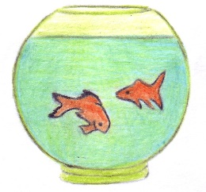
best / I / am / man’s / friend __________________________________

live / we / in / water __________________________________
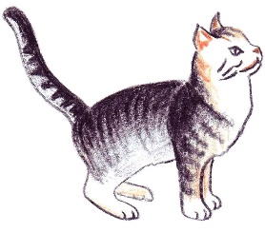

sleep / I / to / like / a / lot __________________________________
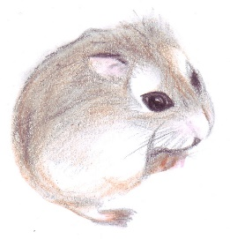

am / I / soft / grey / and __________________________________

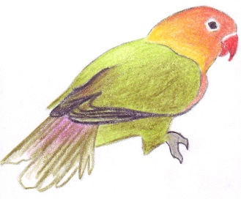
fly / have / I / can / wings / and __________________________________

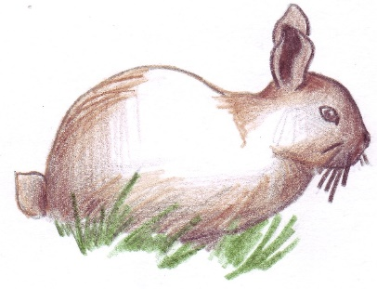
favorite / food/ my / carrots / is __________________________________

