Name: ____________________________ Surname: ____________________________ N^{ber}: ____ Grade/Class: _____
Assessment: _____________________________ | Date: ___________________________________________________
 | Teacher’s signature:  ___________________________ | Parent’s signature:  ___________________________

Write 5 sentences about pets in a pet shop. Use five of the following animals in your sentences.
Dog / Cat / Bird / Parrot / Fish / Goldfish / Turtle / Mouse / Bunny / Rabbit / Frog / Hamster
Example: In the pet shop they have many goldfish.

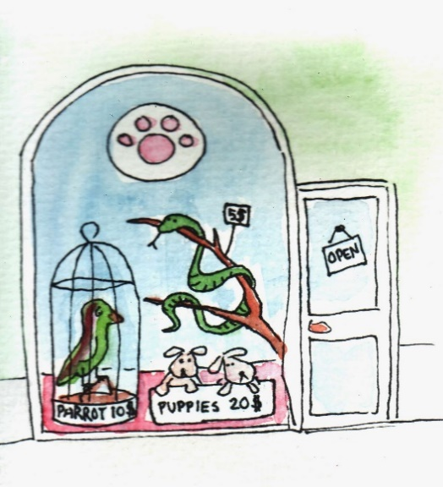
A visit to a pet shop

- _______________________________________________________________________________________
- _______________________________________________________________________________________
- _______________________________________________________________________________________
- _______________________________________________________________________________________
- _______________________________________________________________________________________

