Name: ____________________________ Surname: ____________________________ N^{ber}: ____ Grade/Class: _____
Assessment: _____________________________ | Date: ___________________________________________________
 | Teacher’s signature:  ___________________________ | Parent’s signature:  ___________________________

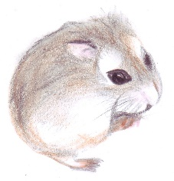
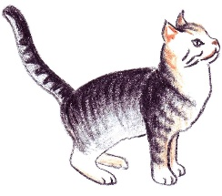
- Fill in the gaps and match the correct word with the pet.
- B _ _ D
- P _ _ _ O T
- _ O _ S _
- H _ M _ _ E _
- D _ _
- _ _ T
- G _ L _ F _ _ H
- _ _ _ G

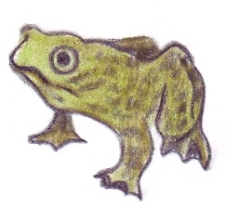
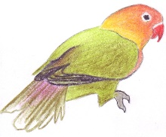

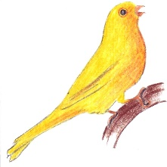

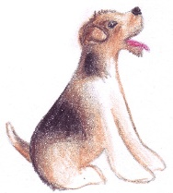

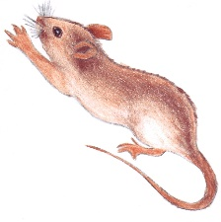
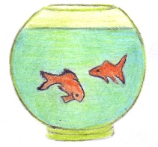

2. What is your favourite pet? ____________________.

3. Which pet don’t you like? ____________________.

