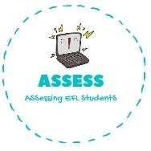
ENGLISH WORKSHEET

TOPIC: ZOO ANIMALS | SUBTOPICS: COMPREHENSION | LEVEL: A2
Name: Surname: N^{ber}: Grade/Class:

Amy and Nicholas go to the Zoo
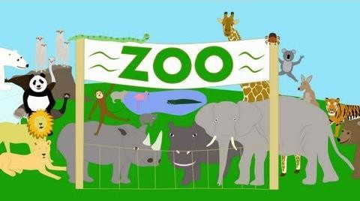

On a sunny Sunday morning, Amy and Nicolas went to the zoo with their parents. Amy wanted to see the small monkeys and the kangaroos with their long tails and strong legs. Nicolas was hoping to see the wolves with their sharp teeth and the bears with their huge claws. When they arrived at the zoo, they started their walk at the elephant arena. The biggest elephant with his long trunk came very near to them. It was very exciting to see the animal so closely. They saw many animals that day. They loved the zebra's pretty stripes and the tall giraffes from Africa with their beautiful spots and long neck. They even got to hold a koala from Australia. When they were hungry, they stopped for lunch and got to have hamburgers, fries and soda. It was a beautiful warm day, so they sat outside near the lions. Amy wondered if the lions would like hamburgers too.
After lunch, Amy and Nicolas went to the petting zoo of farm animals. Here there were all the animals that you would find on a farm, and you could pet them. There were chickens, ducks, sheep, goats, rabbits and pigs. In a paddock were cows. There were even a donkey and a horse that you could ride on for a dollar. After they had seen all the animals in the zoo, Amy and Nicolas agreed that the scaley crocodiles were the scariest of all. They had a wonderful day at the zoo that day. Next weekend they might go to Sea World to visit the fish, dolphins and the penguins. But that is another story.
Comprehension
Who did Amy and Nicholas go to the zoo with? What animals did Amy want to see? What animals did Nicholas want to see? Where did they start their walk through the zoo? What animals were in the petting zoo? What animals could you ride on for a dollar? Which was the scariest animal in the zoo?

Assessing EFL Students

