TOPIC: PETS | SUBTOPICS: COMPREHENSION | LEVEL: A2
Name: ____________________________ Surname: ____________________________ N^{ber}: ____ Grade/Class: _____

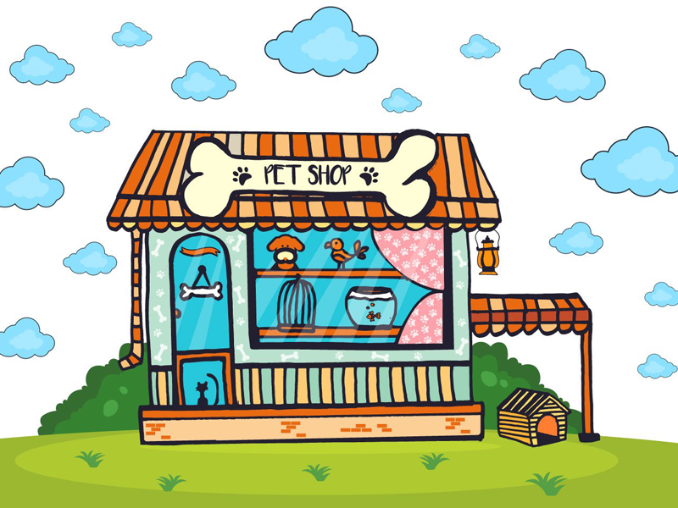
My mother’s pet store

When my mother was a girl, she and her family owned a pet store. She would play with the animals every day. Before school, she would feed the dogs and cats. She would pet the rabbits because they were so fluffy and cute. She would watch the hamsters play in their hamster wheel. Sometimes the frogs and turtles would escape. They would jump and crawl along the floor. My mother would have to catch them and put them back in their tanks. She would make sure the fish, birds and mice had food before she would run to school. At school, she would think of all the animals in the pet store and would draw pictures of them. One day at the pet store there was a tall man named Larry, who bought lots of things. His children had always wanted pets, so he had decided to surprise them. Larry purchased a puppy and a dog house, a cage with a parrot, and an aquarium full of goldfish. My mother was sad seeing her friends leave, but she was happy they got a lovely new home.

Comprehension
What animal did the story tellers mother like to pet? ____________________________________________
What animals did the tall man buy? __________________________________________________________
Which animals did she feed before going to school? _____________________________________________
Which animals escaped their cages? _________________________________________________________

