Name: ____________________________ Surname: ____________________________ N^{ber}: ____ Grade/Class: _____
Assessment: _____________________________ | Date: ___________________________________________________
 | Teacher’s signature:  ___________________________ | Parent’s signature:  ___________________________

Where do the animals live? Listen, number and draw a line to the correct picture.
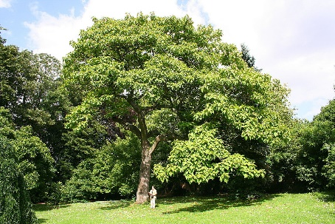
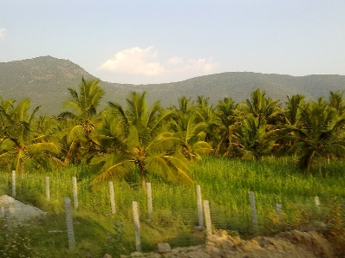
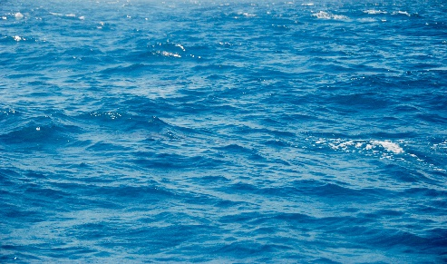

A. B. C.
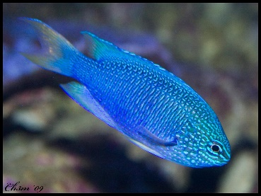
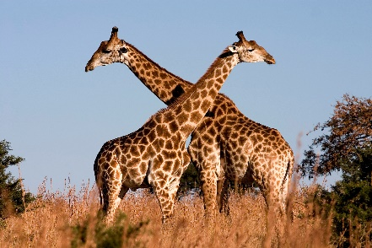
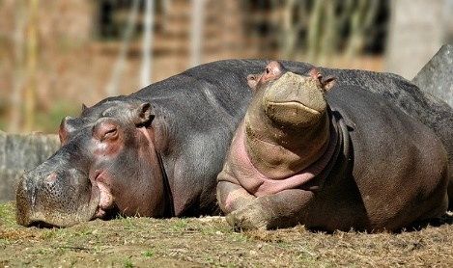

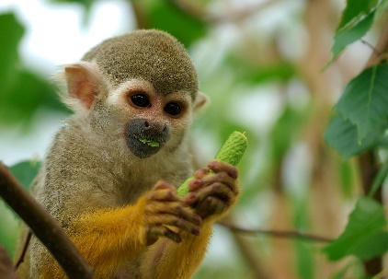
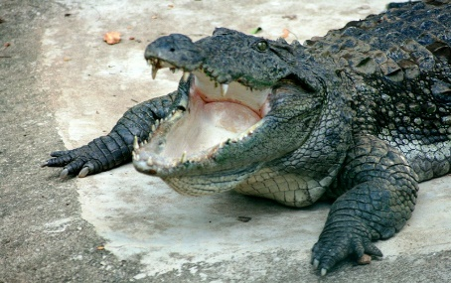
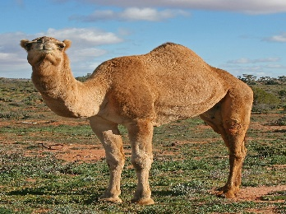

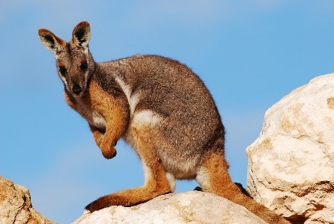
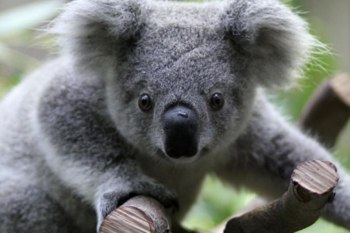
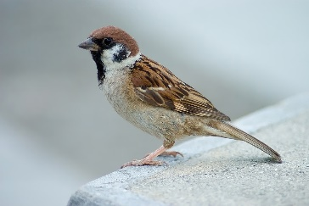

- Monkeys live in trees.
- Fish live in the water.
- Camels live on land.
- Birds live in trees.
- Giraffes live on land.
- Kangaroos live on land.
- Hippos live both on land and in the water.
- Koalas live in trees.
- Crocodiles live both on land and in the water.

