Name: ____________________________ Surname: ____________________________ N^{ber}: ____ Grade/Class: _____
Assessment: _____________________________ | Date: ___________________________________________________
 | Teacher’s signature:  ___________________________ | Parent’s signature:  ___________________________

Listen and color the animals according to the instructions.

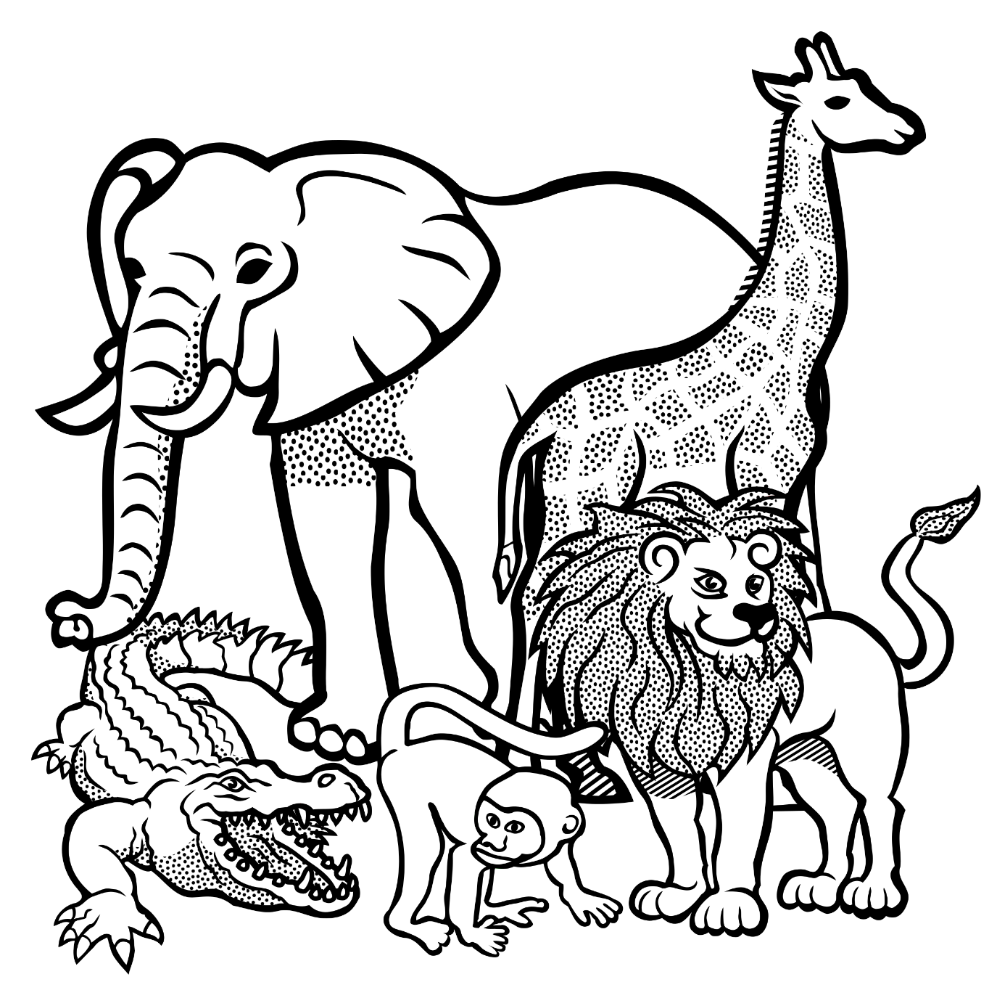

- The crocodile is dark green
- The crocodile has a red tongue
- The crocodile has black claws.
- The monkey has a yellow face.
- The monkey has a black tail.
- The monkey has a brown body
- The lion has a yellow mane.
- The lion has a brown body.
- The lion has a yellow tail.
- The giraffe has orange spots.
- The body of the giraffe is yellow.
- The elephant is grey.
- The elephant has white tusks.
- The elephant has black feet.

