Name: ____________________________ Surname: ____________________________ N^{ber}: ____ Grade/Class: _____
Assessment: _____________________________ | Date: ___________________________________________________
 | Teacher’s signature:  ___________________________ | Parent’s signature:  ___________________________
At the farm. Circle the correct answer.
1a. What animal are they talking about?
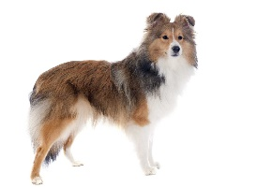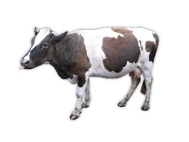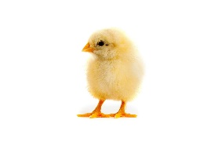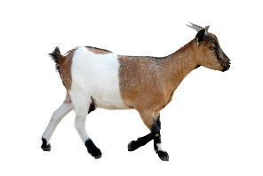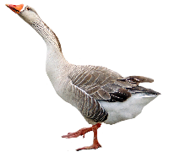
1b. How old is Rosy? 1) Three years old 2) Four years old 3) Six years old 4) Seven years old

2. Which bird are they talking about?
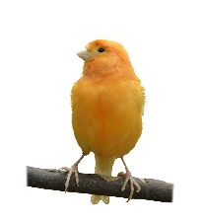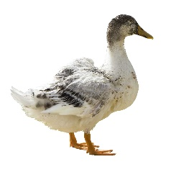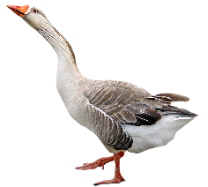
3a. What farm animal can they see?
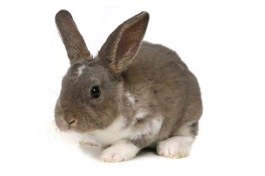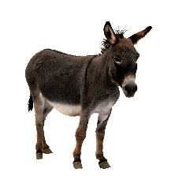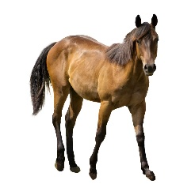
3b. Where can they see the farm animal? a) Near the barn b) Near the house c) Near the well d) Near the gate

4. Which animal has babies called kittens?
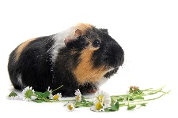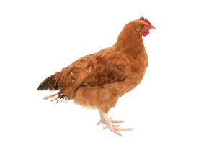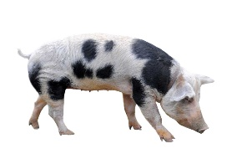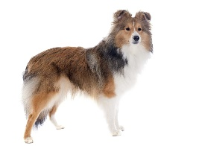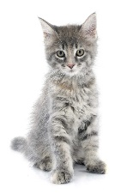
Transcripts.
1.
Man: Look, there is a cow.
Woman: Yes, there is. It is a big cow.
Man: The cow is brown with white legs
Woman: Yes, that cow is called Rosy.
Man: Rosy is old. She is seven years old.
2.
Woman: What is that bird called?
Man: It is a goose.
Woman: The goose is white.
Man: If you have many of them, they are together called geese.
3.
Man: Do you like rabbits?
Woman: Yes, I do. They are very soft and cuddly.
Man: Can you see any rabbits?
Woman: Yes, I see one over there near the house.
4.
Woman: Look, that cat has three babies.
Man: Yes, they are called kittens.
Woman: They are so cute.
Man: How many kittens are there?
Woman: There are four kittens.

Key:
- Cow
- 7 years old
- Goose
- Rabbit
- Near the house
- Cat

