Name: ____________________________ Surname: ____________________________ N^{ber}: ____ Grade/Class: _____
Assessment: _____________________________ | Date: ___________________________________________________
 | Teacher’s signature:  ___________________________ | Parent’s signature:  ___________________________

Listen and add the correct numbers in the circles.

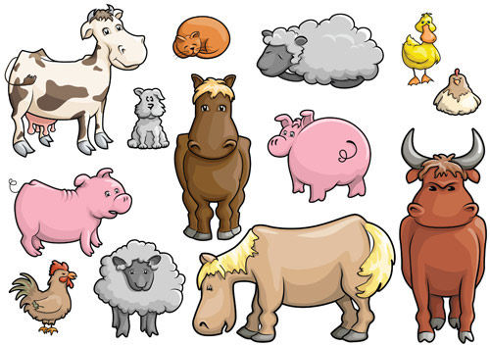

Transcript:
Number one is a cat
Number two is two sheep
Number three is two horses
Number four is a bull
Number five is two chickens
Number six is two pigs
Number seven is a duck

