Name: ____________________________ Surname: ____________________________ N^{ber}: ____ Grade/Class: _____
Assessment: _____________________________ | Date: ___________________________________________________
 | Teacher’s signature:  ___________________________ | Parent’s signature:  ___________________________

Listen and write the names of the animals. Then write the correct animal and age in the sentences.
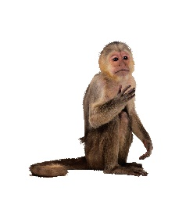
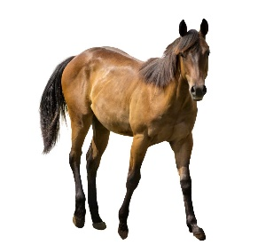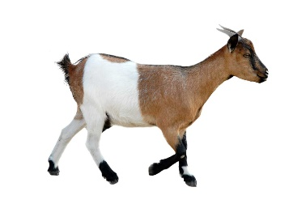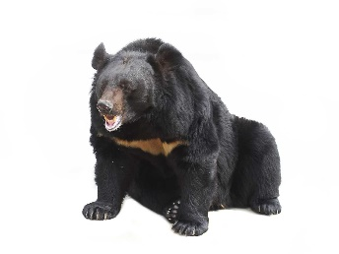
_______________ _______________ _______________ _______________

The ______________ lives in a tree.
The ______________ in a forest.
The ______________ lives on a farm.
The ______________ lives in the mountains.

Only the ______________ likes to eat hay.
The ______________ likes to eat honey.
Bananas are the ______________’s favorite food.
The ______________ does not like carrots.

The ______________ is _________ years old.
The ______________ is _________ years old.
The ______________ is _________ years old.
The ______________ is _________ years old.

Transcript:
The horse’s name is Ben.
The goat’s name is Tom.
The bear’s name is Alice.
The monkey’s name is Rose.

The monkey lives in a tree.
The bear lives in a forest.
The horse lives on a farm.
The goat lives in the mountains.

Only the horse likes to eat hay.
The bear likes to eat honey.
Bananas are the monkey’s favorite food.
The goat does not like carrots.

The horse is seven years old.
The monkey is four years old.
The bear is ten years old.
The goat is three years old.

