Name: ____________________________ Surname: ____________________________ N^{ber}: ____ Grade/Class: _____
Assessment: _____________________________ | Date: ___________________________________________________
 | Teacher’s signature:  ___________________________ | Parent’s signature:  ___________________________

1) Listen and number.
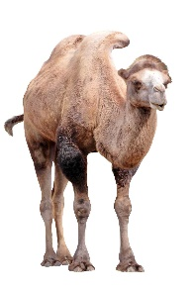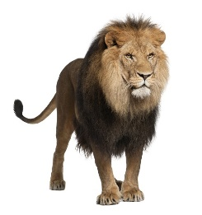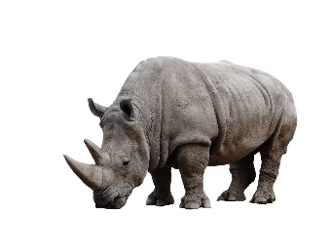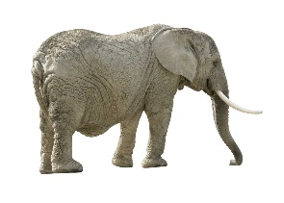

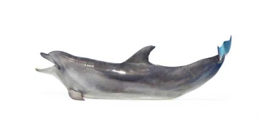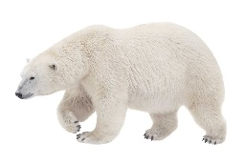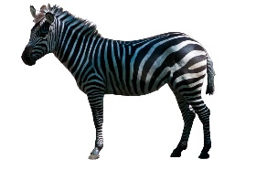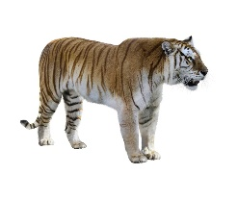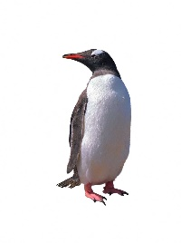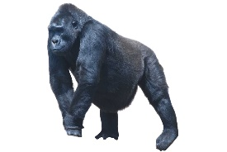

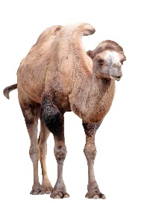
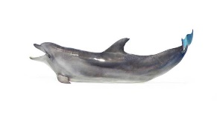
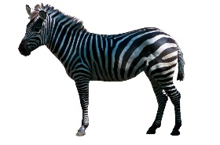
2) Listen and tick five of the animals.
1.
a) b) c) d)
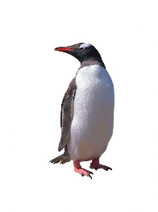
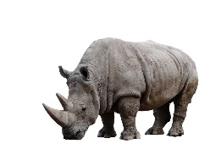
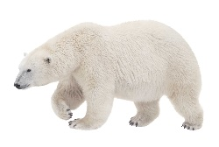
2.
a) b) c) d)

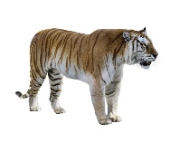
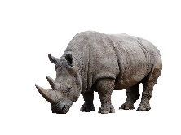
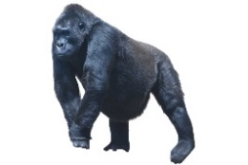
3.
a) b) c) d)

Transcript:

- A polar bear
- A zebra
- A dolphin
- A monkey
- An elephant
- A camel
- A tiger
- A panda
- A gorilla
- A lion
- A penguin
- A rhinoceros

Transcript 2:
- The panda is black and white. It comes from China.
- You can ride this animal. You find it in deserts.
- This animal likes to climb trees and likes to eat bananas.
- This animal has got stripes.
- This animal lives in a cold climate.

