Name: ____________________________ Surname: ____________________________ N^{ber}: ____ Grade/Class: _____
Assessment: _____________________________ | Date: ___________________________________________________
 | Teacher’s signature:  ___________________________ | Parent’s signature:  ___________________________

At the zoo.
- What animals are they talking about? Circle the correct animals.
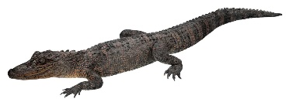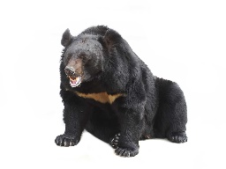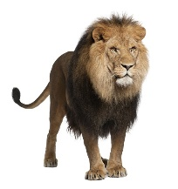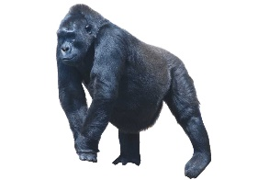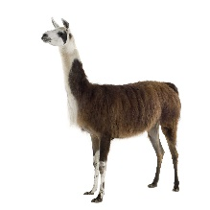

- What is the name of this animal? Z _ _ _ _
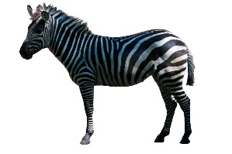
- Which zoo animals live in or near the water? Circle the correct animals.
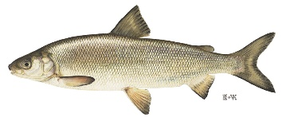
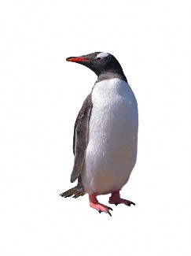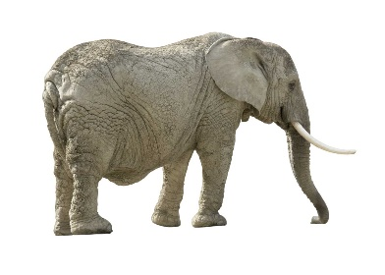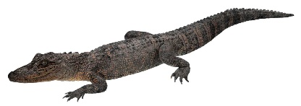

Which animals are the man and the woman talking about? Circle the correct answers.
- Elephant b) Lion c) Tiger d) Frog e) Snake f) Dolphin i) Panda
- k) Giraffe

Transcripts.
1.
Man: Look, there is a lion.
Woman: Yes, the lion is in the cage.
Man: It is a very big lion.
Woman: Next to the lion there is a black gorilla.
Man: The gorilla looks scary.
Woman: There is also a brown bear.
2.
Woman: What is that animal called?
Man: It is a zebra.
Woman: That is a strange name for a horse.
Man: It is not a horse, it is a zebra.
Woman: How do you spell that?
Man: Z - E - B - R - A
3.
Man: Which animals in the zoo live in or near the water?
Woman: I think penguins live near the water. And crocodiles. Fish live in the water.
Man: Can you see any rabbits?
Woman: Yes, I see one over there near the house.
4.
Woman: Look, that is a tiger.
Man: Yes, the tiger has stripes. There is a snake.
Woman: Oh no, I am scared of snakes.
Man: Before we leave the zoo, we should go and see the panda.
Woman: Yes, let’s do that. They are very cute and love eating bamboo.

Key:
- Lion, gorilla, bear
- Zebra
- Penguin, whale, crocodile
- Tiger, snake, flamingo, polar bear, panda

