Name: ____________________________ Surname: ____________________________ N^{ber}: ____ Grade/Class: _____
Assessment: _____________________________ | Date: ___________________________________________________
 | Teacher’s signature:  ___________________________ | Parent’s signature:  ___________________________

Read the text about the rooster and answer the questions.

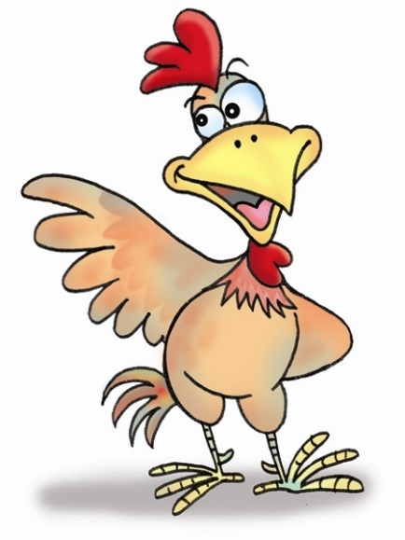
Hello. I am a rooster. I live on a farm outside the city. The people in the big house call me Raga. I wake up everybody in the big house up at 7 am. I live with the chickens. Our home is called a chicken coop. Another word is a hen house.

- What is the animal called? ______________________________

- Where does he live? ______________________________

- Who is he living with? ______________________________

- What is the name of his home? ______________________________

- What is the name of the rooster ? ______________________________

