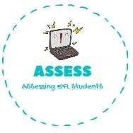
ENGLISH EXAM
Reading

Name: Surname: N^{ber}: Grade/Class:
Assessment: | Date:
 | Teacher’s signature:  _ | Parent’s signature:

Read about the pets and link together the question and the answer.

A
Do you have a pet?
It’s a turtle.
1)

B
What is your dog’s name?
It’s a tail.
2)

C
What is that animal called?
Yes, I have a dog.
3)

D
What does a rabbit eat?
It’s a gold fish.
4)

E
What is that on the horse?
It eats carrots.
5)

F
What is kind of fish is that?
His name is Buster.
6)

Assessing EFL Students

