Name: ____________________________ Surname: ____________________________ N^{ber}: ____ Grade/Class: _____
Assessment: _____________________________  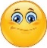  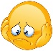  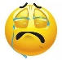 | Date: ___________________________________________________
 | Teacher’s signature:  ___________________________ | Parent’s signature:  ___________________________

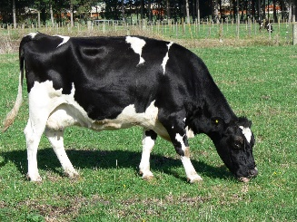
Read and look. Put a tick if it’s correct and a cross if it’s wrong .

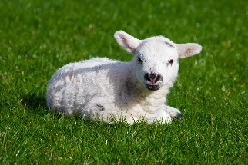

- The cow is eating grass.

- The sheep is standing.

- The donkeys are playing.

- The horse is sleeping.

- The duck is swimming.

- The chicken is on the hay.

- The goats are black.

