Name: ____________________________ Surname: ____________________________ N^{ber}: ____ Grade/Class: _____
Assessment: _____________________________  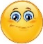  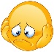  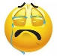 | Date: ___________________________________________________
 | Teacher’s signature:  ___________________________ | Parent’s signature:  ___________________________
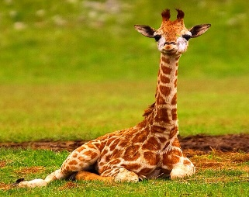
Read the sentences and tick if it’s correct and if it is wrong.

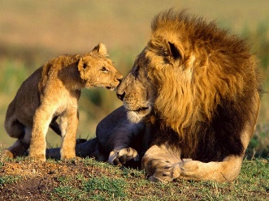

- The giraffe is eating leaves.

- The lions are running.

- The elephants are in the water.

- The crocodile is swimming.

- The hippo is sleeping.

- The kangaroo is jumping.

- The koala is sitting in a tree.

