Name: ____________________________ Surname: ____________________________ N^{ber}: ____ Grade/Class: _____
Assessment: _____________________________  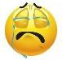  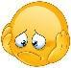 | Date: ___________________________________________________
 | Teacher’s signature:  ___________________________ | Parent’s signature:  ___________________________

Look at the picture and read the statements. Answer True or False.
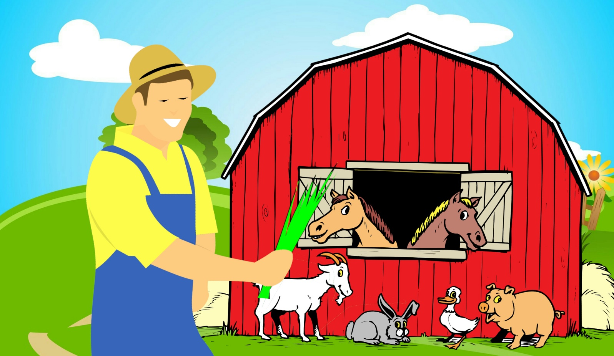

- The farmer has a red shirt. _______________
- The goat is white. _______________
- There are three horses. _______________
- The rabbit is black. _______________
- There are two pigs. _______________
- There are two clouds. _______________
- The farmer’s hat is blue. _______________
- There is a duck in front of the barn. _______________
- There are two flowers. _______________
- The grass is green. _______________

