Name: ____________________________ Surname: ____________________________ N^{ber}: ____ Grade/Class: _____
Assessment: _____________________________ | Date: ___________________________________________________
 | Teacher’s signature:  ___________________________ | Parent’s signature:  ___________________________

Look at the picture and answer the questions.
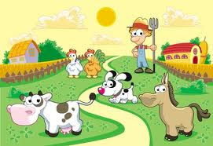
Is it daytime?
How many dogs are there in the picture?
What colour are the roofs of the houses?
How many spots does the cow have?
How many clouds are there?
Is the chicken blue?
What is the farmer wearing?
Does the horse have a tail?
What colours are dog’s ears?
Is the grass yellow?
Is the rooster next to the cow?

