Name: ____________________________ Surname: ____________________________ N^{ber}: ____ Grade/Class: _____
Assessment: _____________________________ | Date: ___________________________________________________
 | Teacher’s signature:  ___________________________ | Parent’s signature:  ___________________________

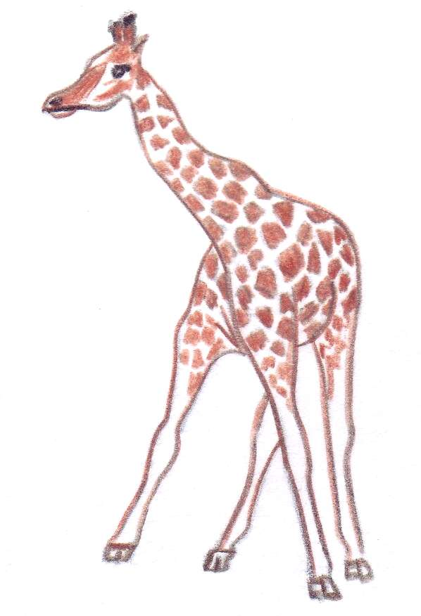
Speak about animals. Work in pairs. Talk about the different animals. Which ones you like and which ones don’t you like? Why do you like them or don’t like them? Do you know all the animals in the pictures?
