Name: ____________________________ Surname: ____________________________ N^{ber}: ____ Grade/Class: _____
Assessment: _____________________________ | Date: ___________________________________________________
 | Teacher’s signature:  ___________________________ | Parent’s signature:  ___________________________

1) Fill in the gaps.

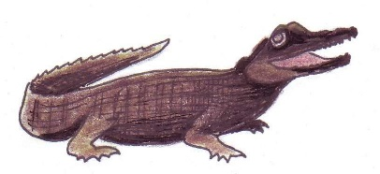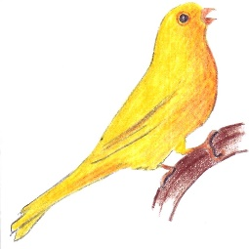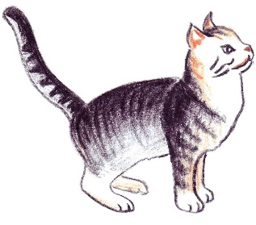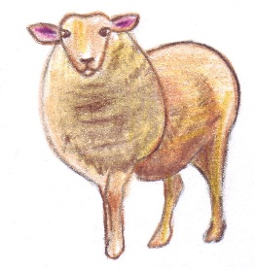
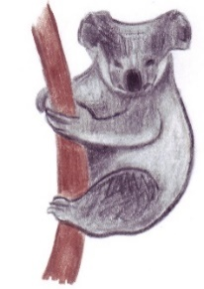
C _ _ C _ _ _ _E _ I _ _ C _ _ _ H E _ _
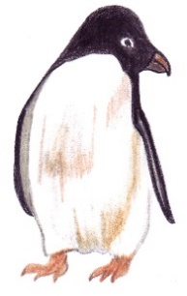
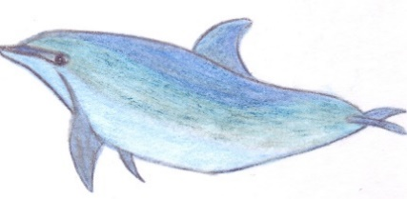
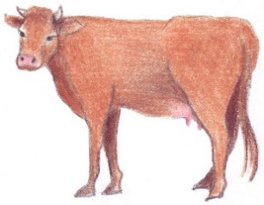

_ O _ D _ _ P _ _ _ K _ _ _ A _ E _ G _ _ N

2. Write the plural forms for the pictured animals:

1. ________________________
2. ________________________
3. ________________________
4. ________________________
5. ________________________
6. ________________________
7. ________________________
8. ________________________

Key:

Crocodile – crocodiles
Bird - birds
Cat – cats
Sheep - sheep
Cow – cows
Dolphin – dolphins
Koala – koalas
Penguin – penguins

