ENGLISH WORKSHEET

TOPIC: ZOO ANIMALS | SUBTOPICS: VOCABULARY |  | LEVEL: A2
Name: ____________________________ Surname: ____________________________ |  | N^{ber}: ____ Grade/Class: _____

Vocabulary

Match the words to the pictures.
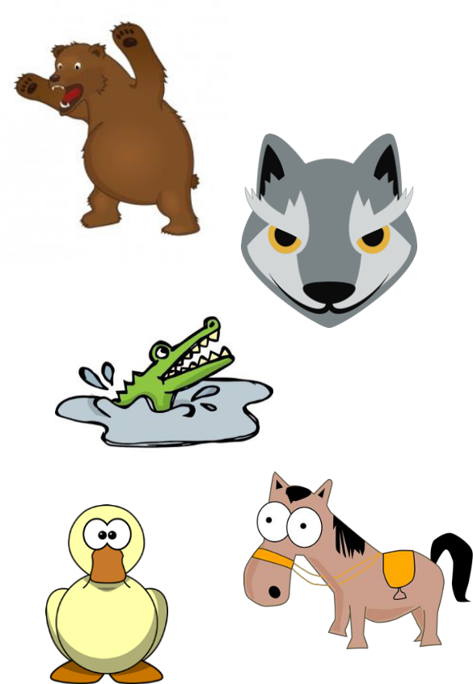
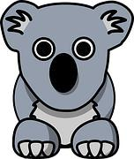

Elephant
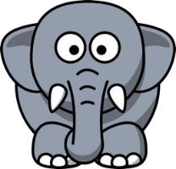

Wolf

Bear
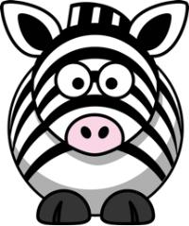

Crocodile
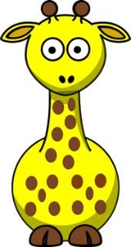

Horse

Duck

Zebra

Giraffe

Koala

- The elephant has a long __________

- The wolf has pointy _________

- The bear has big __________

- The crocodile has sharp ___________

- The horse has a soft __________

- The zebra has many ___________

- The duck has shiney ___________

- The giraffe has brown ___________

- The koala has a short ____________

10.The kangaroo has strong ________

Assessing EFL Students

mane

feathers

claws

stripes

spots

nose

teeth

legs

ears

trunk

