Name: ____________________________ Surname: ____________________________ N^{ber}: ____ Grade/Class: _____
Assessment: _____________________________  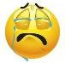  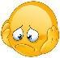  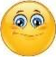 | Date: ___________________________________________________
 | Teacher’s signature:  ___________________________ | Parent’s signature:  ___________________________

Animal body parts. Draw a line to the right words from each animal picture
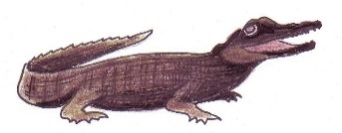 wings teeth horns 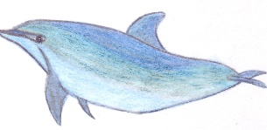
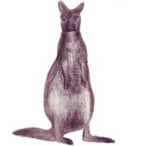
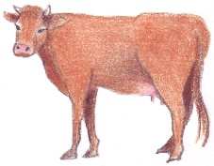 claws fur tail
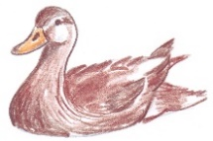
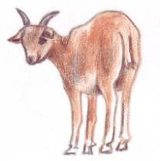
flippers trunk feathers
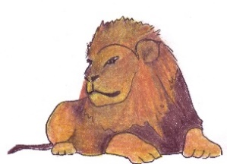
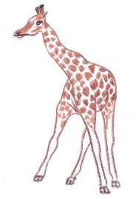 hair ears beak

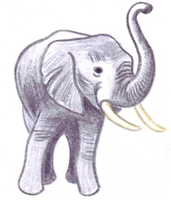
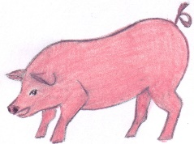 fin paws mane

