Name: ____________________________ Surname: ____________________________ N^{ber}: ____ Grade/Class: _____
Assessment: _____________________________ | Date: ___________________________________________________
 | Teacher’s signature:  ___________________________ | Parent’s signature:  ___________________________

1) Look at the pictures and fill in the gaps and circle the correct answer.

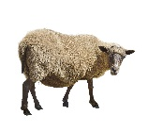
a)
Do you like s__ __ __p?

Yes, I do. / No, I don’t.
Yes, I do. / No, I don’t.

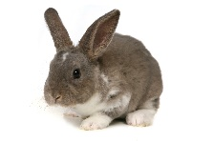
b)
Do you like r __ b __ __ ts?

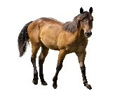
c)
Do you like __ o__ __ es ?
Yes, I do. / No, I don’t.

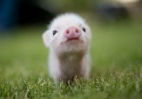
d)
Do you like p __ g __?
Yes, I do. / No, I don’t.
Yes, I do. / No, I don’t.

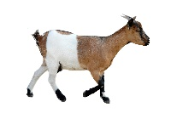
e)
Do you like g__ __ts?

2) And you?
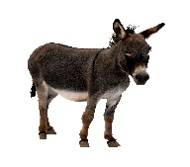
a)
Do you like donkeys?
______ , _____ ______.

______ , _____ ______.

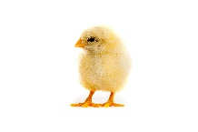
b)
Do you like chickens?

