Name: ____________________________ Surname: ____________________________ N^{ber}: ____ Grade/Class: _____
Assessment: _____________________________ | Date: ___________________________________________________
 | Teacher’s signature:  ___________________________ | Parent’s signature:  ___________________________

1) Look at the pictures, fill in the gaps and circle the correct answer.

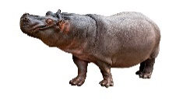
a)
Do you like h__ __ __os?
Yes, I do. / No, I don’t.
Yes, I do. / No, I don’t.

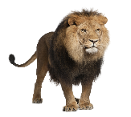
b)
Do you like __ __on__?

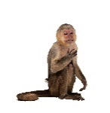
c)
Do you like m__ __k__ys?
Yes, I do. / No, I don’t.

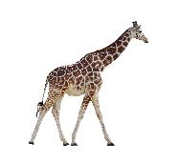
d)
Do you like g __ r __ f __es?
Yes, I do. / No, I don’t.
Yes, I do. / No, I don’t.

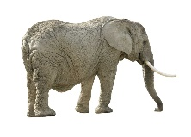
e)
Do you like e __e __ h __ __ ts?

2) And you?

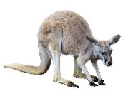
a)
Do you like kangaroos?
______ , _____ ______.

______ , _____ ______.

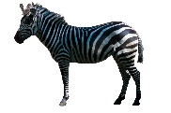
b)
Do you like zebras?

