Name: ____________________________ Surname: ____________________________ N^{ber}: ____ Grade/Class: _____
Assessment: _____________________________ | Date: ___________________________________________________
 | Teacher’s signature:  ___________________________ | Parent’s signature:  ___________________________

- Write the following sentences in the negative form. Is + not = isn’t. Are + not = aren’t. Use isn’t and aren’t.
Example: The elephant is big. The elephant isn’t big.
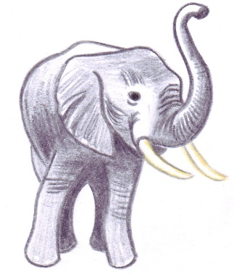
The lions are hungry. ___________________________________________________
The giraffe is hungry. ___________________________________________________
The birds are beautiful. ___________________________________________________
The snake is long. ___________________________________________________
The crocodile is dangerous. ___________________________________________________
The frogs are green. ___________________________________________________

- Make questions from the sentences.
Example: The bear is sleeping. Is the bear sleeping?
The penguins are swimming. ___________________________________________________
The hippo is in the water. ___________________________________________________
The monkeys are sitting in the tree. ___________________________________________________
The camel is drinking water. ___________________________________________________
The pandas are black and white. ___________________________________________________
The zebras are beautiful. ___________________________________________________

