Name: ____________________________ Surname: ____________________________ N^{ber}: ____ Grade/Class: _____
Assessment: _____________________________ | Date: ___________________________________________________
 | Teacher’s signature:  ___________________________ | Parent’s signature:  ___________________________

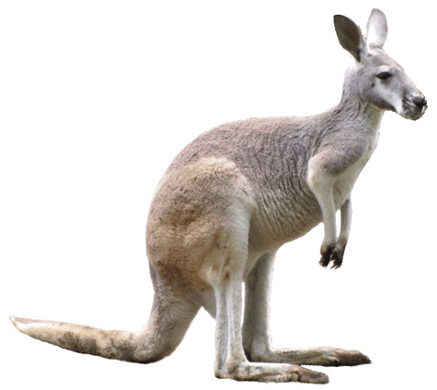
Match the two sections and write the full sentence.

A crocodile
A dolphin
A giraffe
A kangaroo
A lion
A snake
A zebra
An elephant

can jump using two legs
can swim
has a long neck
has a mane
has a trunk
has no legs
has sharp teeth
is striped in black and white

- ______________________________________________________________________

- ______________________________________________________________________

- ______________________________________________________________________

- ______________________________________________________________________

- ______________________________________________________________________

- ______________________________________________________________________

- ______________________________________________________________________

- ______________________________________________________________________

