Name: ____________________________ Surname: ____________________________ N^{ber}: ____ Grade/Class: _____
Assessment: _____________________________ | Date: ___________________________________________________
 | Teacher’s signature:  ___________________________ | Parent’s signature:  ___________________________

Write questions for the sentences.
Example: The pig is dirty. Is the pig dirty?
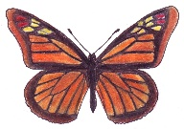The butterfly is pretty. ________________________________________
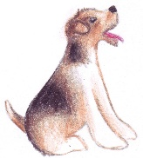The dog is sitting. ________________________________________
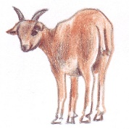The goat is watching me. ________________________________________
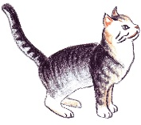The cat is playing. ________________________________________
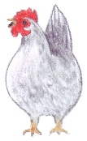 The chicken is laying eggs. ________________________________________
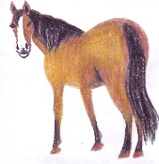 The horse has a black tail. ________________________________________’
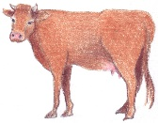 The cow is hungry. ________________________________________

