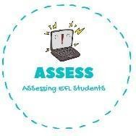
Look at the picture and rewrite the sentence.
Name: Surname: N^{ber}: Grade/Class:
Assessment: | Date:
 | Teacher’s signature: | Parent’s signature:

ENGLISH EXAM
Writing

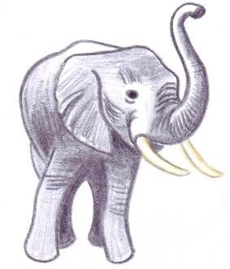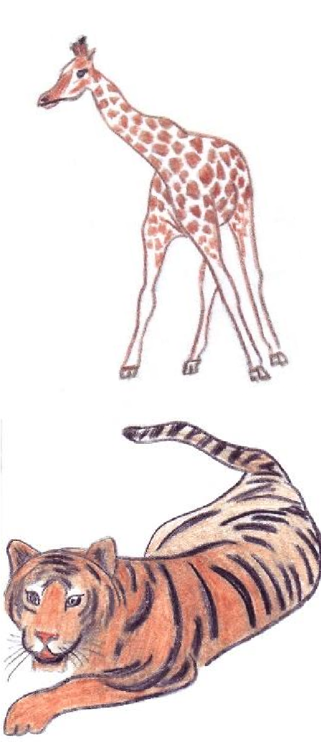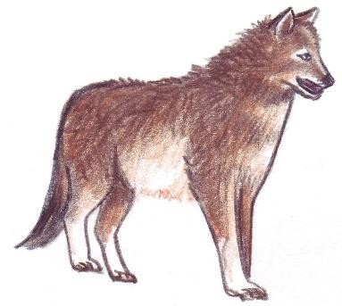

big / I / am / grey /and / I / trunk / have

longest / have / the / neck / I / of / animal / any

striped / and / coat / a / am / I / have / cat

dog / like / I / look / a

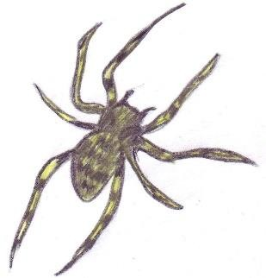
legs / I / hairy / eight / have

Assessing EFL Students

