Name: ____________________________ Surname: ____________________________ N^{ber}: ____ Grade/Class: _____
Assessment: _____________________________ | Date: ___________________________________________________
 | Teacher’s signature:  ___________________________ | Parent’s signature:  ___________________________
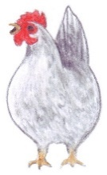
Look at the picture and rewrite the sentence.

lay / I / eggs / live / and / farm / on / a ____________________________________
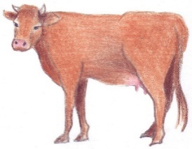

make / milk / I ____________________________________
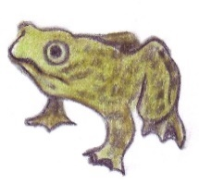

small / am / I / have / but / I / eyes / big ____________________________________
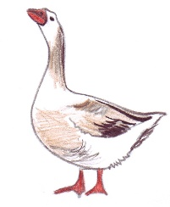

a / I / and / have / beak/ feathers ____________________________________

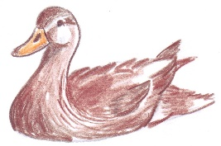
swim / a / can / pond / I / in ____________________________________
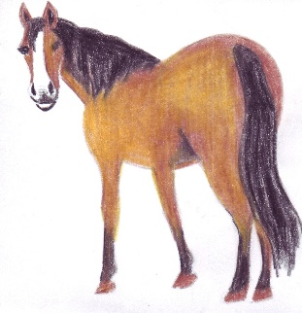

me / ride/ can / people / on ____________________________________

