Name: ____________________________ Surname: ____________________________ N^{ber}: ____ Grade/Class: _____
Assessment: _____________________________ | Date: ___________________________________________________
 | Teacher’s signature:  ___________________________ | Parent’s signature:  ___________________________

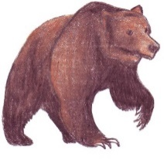
Look at the picture and rewrite the sentence.

sleep / winter / during / I __________________________________
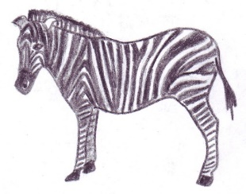

white / and / black / I / have / stripes __________________________________

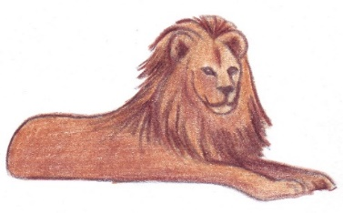
big / cat / am / I __________________________________

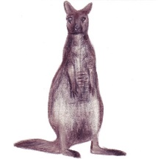
come / I / from / Australia / __________________________________

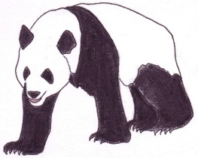
China / come / I / from / eat / and / I / bamboo __________________________________

Antarctica / live / in / and / I / fish / eat __________________________________
